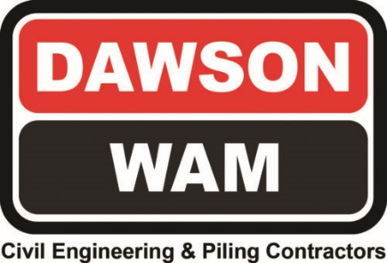
www.dawsonwam.co.uk
Head Office: DAWSON-WAM LTD. Lisdoonan, Belfast Road, Saintfield, Co. Down TB24 7EP
Tel: 028 9081 3105 Fax: 028 9081 2033 Accounts Fax: 028 9081 5163 Estimating Fax: 028 9081 5536

Dear Sir/Madam,

CAMPBELTOWN FLOOD PROTECTION SCHEME

The purpose of this letter is to keep you updated on the progress of the Campbeltown Flood Protection Scheme.
This is a £15million major engineering scheme which will put measures in place to reduce the impact of flooding on residents and businesses in Campbeltown.
Argyll and Bute Council have appointed DAWSON WAM to deliver this project.
We intend to commence drainage works in your area on Monday 23rd January 2023. These will include:
- Excavating drainage track on Main Street and Castlehill and installing new drainage and gullies
- Reinstating road temporarily until all drainage is complete
- Resurfacing of Main Street & Castlehill

To make sure these vital works can go ahead safely, temporary traffic management will be installed. There will also be parking restrictions in place on Castlehill to enable drainage to be installed
The overall works as part of this phase will include new pipelines will be built under roads throughout the town to increase the capacity of the drainage system so that it can better cope with heavy rainfall.
Many of these new pipelines will lead into a storage tank which will be built underneath Burnside Square.
This will safely store water and allow it to slowly discharge. Burnside Square has been chosen for this because it is at a low point in the town and provides a clear open space to build the tank under. Once this element of the scheme is finished people will see no difference – the tank will be hidden underground.
This aspect of the scheme also provides an opportunity to look at how Burnside Square should or could be used in the future given that the Square itself is going to be completely dug to allow the tank to be installed, which presents a good opportunity to possibly redesign the Square. Argyll and Bute Council will be following up with you directly to discuss options and to get your ideas for the Square.
We are aware the scheme will cause disruption and we apologise in advance, but these works are vital to ensure peoples’ properties and businesses are not flooded in the way they have been in the past because of an out of date, undersized sewer system which is regularly overwhelmed.
There is a dedicated project web page which Argyll and Bute Council have set up which has background on the project and where you can sign up to regular updates. It is available at the following link: www.argyll-bute.gov.uk/campbeltown-flood-protection-scheme
If you have any queries about the works, please contact our Site Team at campbeltown@dawsonwam.co.uk. Any specific queries about the scheme will be picked up by our dedicated Community Liaison Officer.
Yours faithfully,

Adam McKeown
Contracts Manager

On behalf of DAWSON WAM, working with Argyll and Bute Council.

