Supporting Communities Fund Grant Application Signature Guide
The Supporting Communities Fund Grant Application requires the applicant and declaration signatures to be clear and in the correct format. Please note that the applicant and declarant cannot be related.
You need to return all pages of the full signed application form to us. You do not need to return the guidance pages.
We have created this short guide with examples of what can, and cannot, be accepted to help you to complete the application form.

How to return a signed application to us - acceptable electronic signatures and return methods
- Typed Electronic Signatures (regardless of font)
You can type your name into the relevant signature section of the electronic application form using any font.
Please note - if this signature method is used, the completed electronic application must be emailed to us directly, from the email address of either the applicant or declarant, and the email must also include an email from the other confirming that they too have electronically signed the application form, i.e. applicant electronically signs form and emails it to the declarant with a cover note to say that they have electronically signed the form. The declarant then adds their electronic signature to the form and emails the completed electronic form to us at supportingcommunitiesfund@argyll-bute.gov.uk with the original email from the applicant also attached.
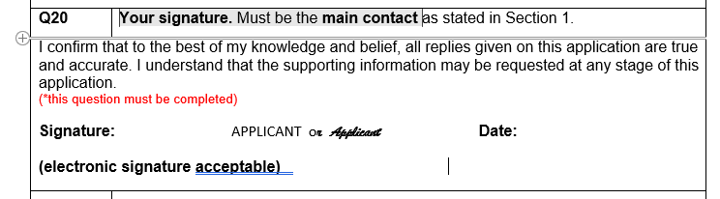

- Create and insert an electronic signature
You can do this by creating an electronic signature in a programme, such as Paint, then copy it into the electronic application form. Once signed, by both applicant and declarant, the form can be emailed to supportingcommunitiesfund@argyll-bute.gov.uk
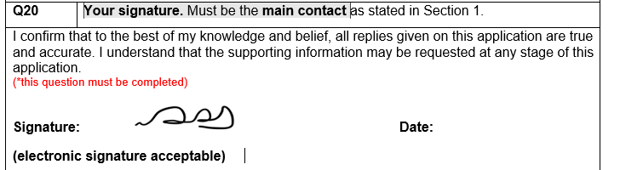

- Print and return by post
You can complete the application form online then print it, or complete a printed application form by hand. Once the applicant and the declarant have added original signatures to the relevant sections of the physical form, it can then be posted to us at the address shown on the final page on the application form or handed in to the Civic Centre, Helensburgh.
- Insertion of electronic signatures via a date stamp using Adobe Signatures
If you have access to a version of Adobe that allows the insertion of date stamped electronic signatures, then you can use this to insert the electronic signatures of both the applicant and declarant into the application form and then email it to supportingcommunitiesfund@argyll-bute.gov.uk

Signatures that we are not able to accept
Examples of the type of signatures we are not able to accept are:
1. Signatures of the applicant and the declarant on separate documents, regardless of format.
2. Photographs or scans of hard copy application forms with “wet signatures”.
Any paper forms which contain written signatures must be returned by post, or handed in, to the Civic Centre, Helensburgh.
3. Typed notifications, or Signatures, of the applicant or declarant sent by email or post without the completed application form attached.
4. Signatures at the wrong part of the application form or on a blank page.
5. Signatures that have been written, photographed, and added to an electronic form, e.g.
