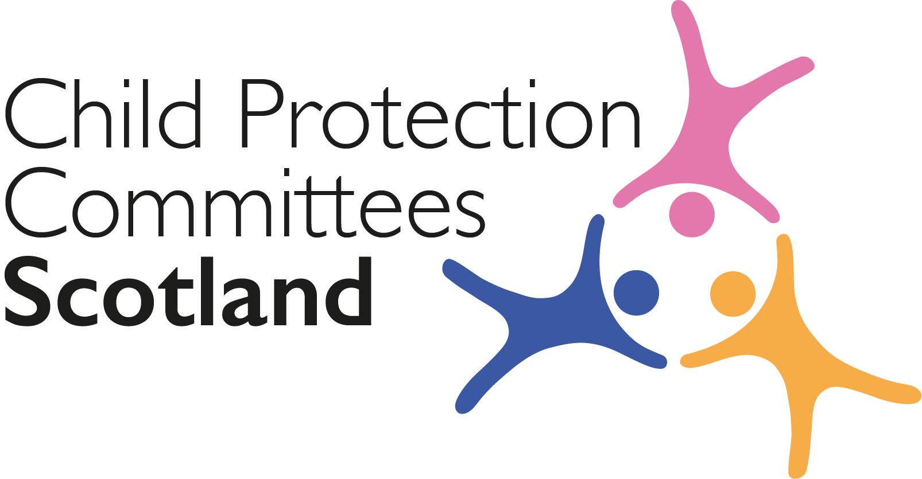
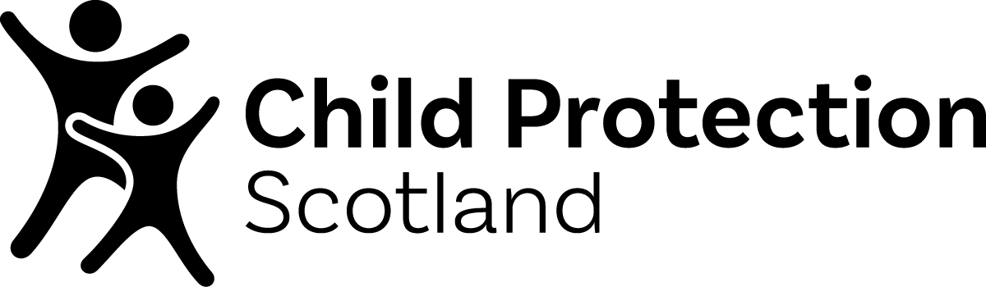

***EMBARGO: the campaign launches on FRIDAY 3 MARCH 2023 at 1000***
Please do NOT use this content ahead of launch

#speakup - a new child protection campaign for children and young people, co-designed by children and young people

Times have been very tough for children and young people in recent years. The pandemic has resulted in a significant increase in young people’s mental health issues, and many families are living in conditions of considerable stress as the cost of living crisis continues to exert its grip.

Encouraging children and young people to speak up if they are experiencing neglect, harm or abuse is more pressing than ever, and a new Child Protection Scotland campaign aims to do just that.

Co-designed in conjunction with three groups of children and young people from partner organisations in Aberdeenshire, Angus and Inverclyde, this new #speakup campaign
is built around ideas which came directly from the three young people’s groups. The campaign
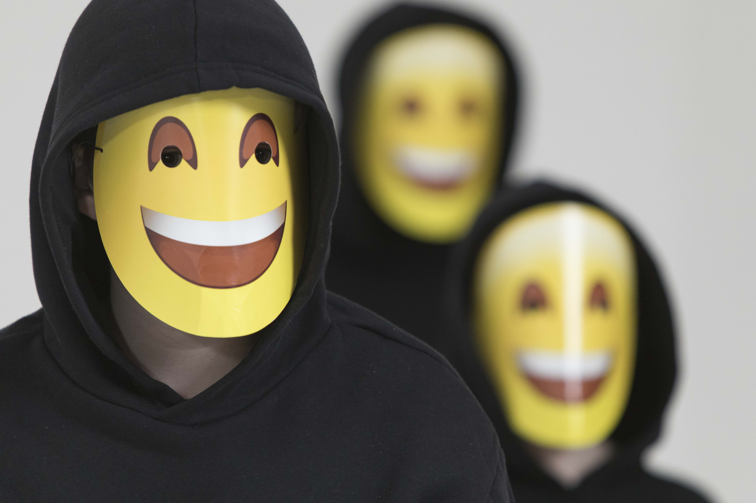
features a dynamic 60” video featuring a choreographed dance and emoji mask symbolism, and urges young people to speak up to a trusted adult if they (or a friend) are experiencing abuse, harm or neglect.
This Scotland-wide #speakup campaign launches on FRIDAY 3 MARCH at 10am and will run for 15 days, ending on the evening of Friday 17 March.

#speakup is a digital campaign aimed at children and young people specifically, and in line with feedback received from the young people in our focus groups, the main 60” campaign video will run as an “advert” on TikTok, Instagram Reels and YouTube.

The full length video will be consolidated by regular posts on our existing public-facing Child Protection Scotland social media streams - @childprotectsco on Facebook, Twitter and Instagram - using additional campaign imagery and a shorter 20” version of the video. Followers will be directed to a new #speakup campaign page on our website (link below).

Child Protection Committees Scotland hopes that you will support the campaign by liking and sharing our social media posts and links to the #speakup campaign webpage, or even creating your own posts using the campaign collateral below. We would also be grateful for any help you can offer to share the video with children and young people in your area.

Supporting content
CPCScotland has prepared a range of campaign content for use by our partners, see pages 3 & 4 below.

Content includes:-

  - Links to long and short versions of the #speakup campaign on the CPS YouTube channel
  - Campaign images
  - Suggested post content for social media
  - campaign hashtags
  - Link to the campaign webpage

We thank you in advance for your support.

Alan Small, Chair

Child Protection Committees Scotland
Thursday 23 February 2023

For further information about the campaign please contact:
Mairi Damer, WORD UP Communications
Tel: 07809 597901 Email: hello@wordupscot.co.uk

#speakup CAMPAIGN CONTENT

- Campaign videos
There are 4 versions of the campaign video available on the Child Protection Scotland YouTube channel. Both the longer 1 minute version and the shorter 20 second versions are available in landscape and vertical formats.

NB #1 The YouTube videos will not be live until 10am on FRIDAY 3 MARCH

NB #2 If you require downloadable versions of any of the videos, please contact Mairi on hello@wordupscot.co.uk and she will arrange a WeTransfer of the file/s.

The full 60” second campaign video in LANDSCAPE format can be found here
https://youtu.be/vBLF2I5SB0Y

The full 60” second campaign video in VERTICAL format can be found here
https://youtu.be/LbDJUj7Yx9M

The shorter 20” second campaign video in LANDSCAPE format can be found here
https://youtu.be/Ls8rlrFW_44

The shorter 20” second campaign video in VERTICAL format can be found here
https://youtube.com/shorts/MF5zBWOs-XM

2. Campaign images
CPS have a range of still images which you are welcome to use on your own social media streams. We have attached a few here, but if you require more, please contact Mairi on hello@wordupscot.co.uk and she will arrange a WeTransfer of the file/s.

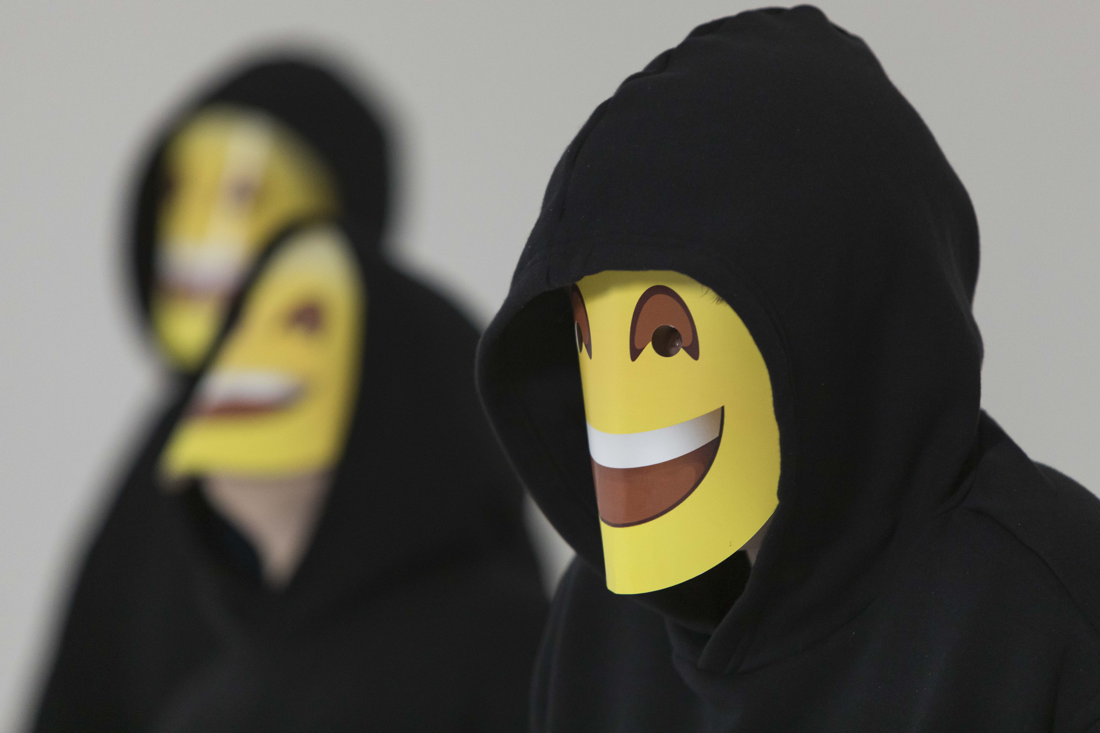

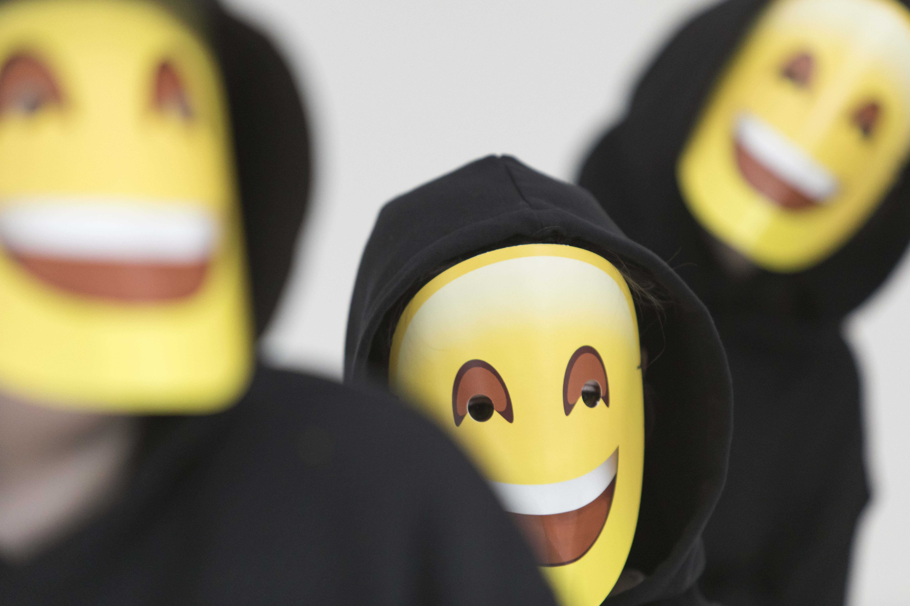

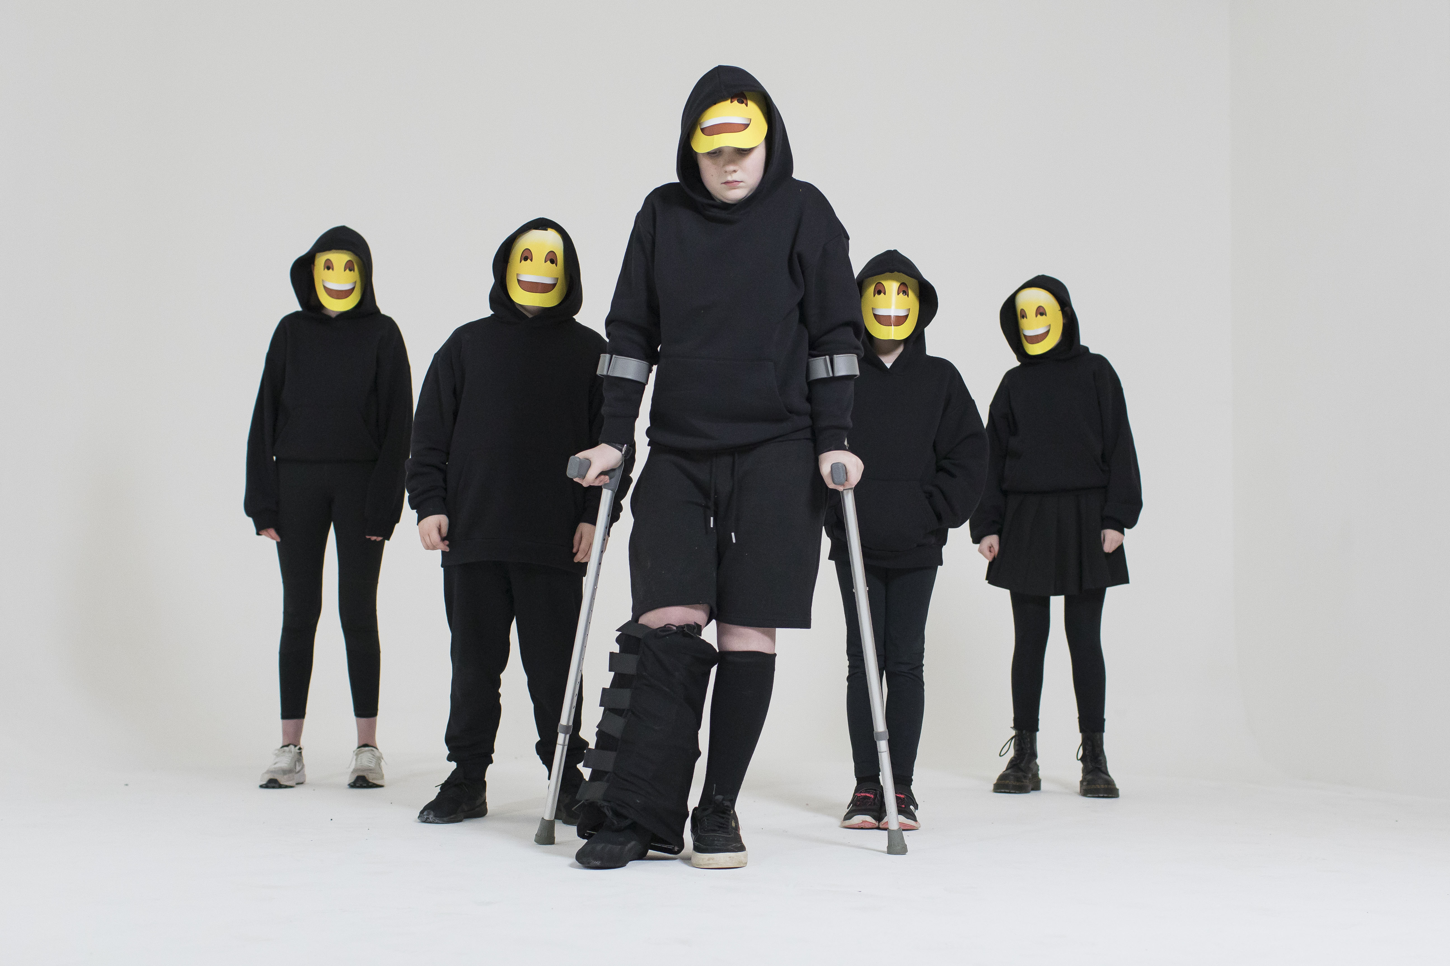

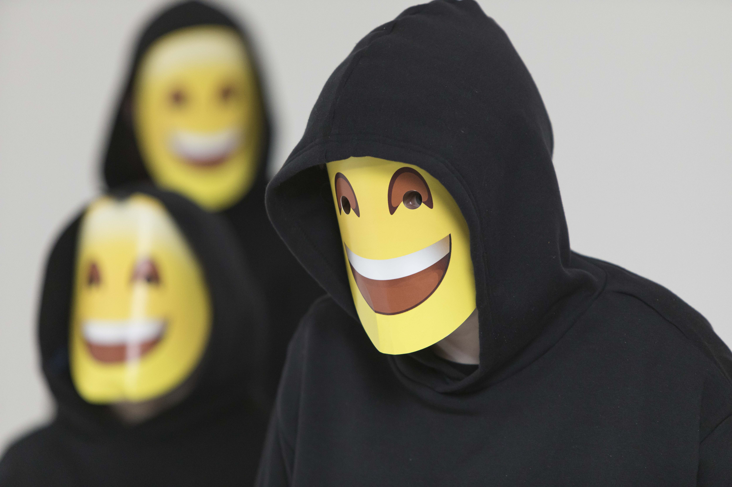

3. Suggested post content

- Some children put on a happy face even if they’re being neglected or abused. If that’s happening to you, or to a friend, it’s important to ask for help #speakup
- Some children put on a bit of a mask to hide that they’re having a bad time. If you, or any of your friends, is being abused or neglected, try and ask an adult you trust for help #speakup
- Some children put on a happy face even if they’re being harmed or not looked after properly. If that’s happening to you, or to a friend, it’s important to ask for help #speakup
- In every crowd of young people there can be one person who is putting on a happy face even they are being harmed or abused. If you’re being abused, ask a friend to help you #speakup to a trusted adult
- It can be really scary to #speakup if you’re being abused or neglected at home or by someone else, but try and talk to an adult you trust or click on the link to find ways to get help
- It can be really scary to #speakup if you’re being harmed or not looked after properly at home, but try and talk to an adult you trust or click on the link to find ways to get help
- Some children put on a happy face to hide that they’re being abused or neglected. If you need help, talk to an adult you trust. You can even ask a friend to help you #speakup
- If you’re worried that one of your friends is being neglected, harmed or abused, offer to help them #speakup to a trusted adult
- When children are being abused or harmed they can sometimes hide how they’re really feeling. If that’s happening to you, try and talk to an adult you trust for help and support #speakup
- Child Protection Scotland are encouraging children and young people to #speakup to a trusted adult if they or a friend are being abused or neglected. Check out their website to find out more

4. Campaign hashtag
#speakup

5. Campaign webpage
https://www.childprotection.scot/speak-up/

NB The campaign webpage will not go live until 10am on FRIDAY 3 MARCH

