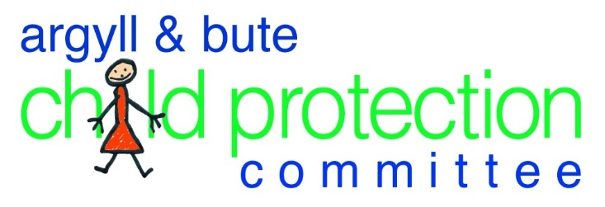

Multi-Agency
Reflective Supervision
Guidance

Date of guidance | January 2023
To be reviewed | January 2025

1. Background & Purpose of the Guidance
  - The Care Inspectorate’s Learning from Significant Case Reviews March 2015 to April 2018 highlight the need for professionals to be able to communicate with each other in a way that is understood and that they are open to professional challenge in an endeavour to ensure that there is a collective understanding about the needs and risks for children and young people. This is echoed in the findings of several Initial Significant Case Reviews undertaken in Argyll & Bute.

  - We acknowledge that professionals need time and space to enable them to collectively reflect on challenging cases that they are working with. Agencies have various case supervision models that allow a practitioner to reflect with a supervisor on a one to one basis, and this allows for professional development and agency assurance about how we work within the systems and processes that ultimately ensure the best outcomes for children and young people. Multi-agency supervision has been agreed by A&B Child Protection Committee as an option which gives an additional layer of opportunity to support practitioners explore practice issues from a multi-agency perspective.

  - Families need to be informed that this professional reflective process exists to support the team around the child to implement the child’s plan effectively. This needs to be outlined to families at the start of the process and any multi-agency supervision sessions held should be recorded in the child’s files.

  - This guidance is for professionals to use:

- When they require an opportunity to meet with the team around the child and other colleagues to explore the complexities of a case and to share personal and agency knowledge and understanding of the practice issues that the case has posed
- Where there is disagreement about the direction of the child’s plan. Coming together in a safe professional space provides the opportunity to reflect on different perspectives and assumptions that will ultimately ensure the team share a clear understanding of any complexities within the case and agree how to progress
- When they are experiencing multi agency challenges in their understanding of a case
- When they feel that they are ‘stuck’ in the processes and systems that we work within
- When there is a need to consider why the planned actions for charge are not being achieved and professional reflection is needed to help to make sense of the reasons why
- When a child has been on the child protection register for 9 months to a year it is good practice to take time to reflect on progress and the effective of the plan in reducing risk and meeting the needs of the child.

2. What is Multi-Agency Reflective Supervision?
  - Multi-Agency work with children and families is often a complex world and many practitioners will identify times when they feel particularly challenged. Single agencies have their own processes and structures to support their staff through these challenges using various supervisory processes that enable a deeper understanding and clarity on a case. However, there will be times that despite this guidance and support, practitioners require a more focused multi-agency reflection process.

  - This model can also be used as a mechanism for a debrief session following a significant event.

  - This process is NOT a child planning meeting or core group and it does not involve the child or family; it is a process that is designed solely to support practitioners undertaking complex case work to gain knowledge and understanding from each other to enable them to better understand those complexities.

  - A reflective supervision session does not have the authority to make changes to a child plan out with core group/ child protection planning meeting/core group or GIRFEC child’s plan meeting process. If during the supervision discussion it is identified that changes to actions or outcomes of the child’s plan are needed, these MUST be taken back to the child’s plan meeting, core group/child protection planning meeting for discussion and agreement with families and CARO (Care and assessment reviewing officer for child protection).

  - This process does not replace single agency Case Supervision processes and is distinct from those occasions where there is a requirement for escalation of concerns through relevant line management systems; it is an opportunity for shared support and learning for the team around the child.

3. Process
3.1 Any practitioner from any agency can request a multi-agency reflective supervision session through discussion and agreement with the case lead professional and partners from the other agencies in the team around the child. There is an expectation that the particular challenges and issues raised by the practitioner will have been discussed through single agency supervisory processes and with the lead professional for the child.
3.2 Someone to facilitate the session will need to be appointed. This should be a professional who is experienced and skilled in delivering case supervision and preferably does not have any direct involvement in the case for example another team lead / manager of supervisory grade. In complex or challenging cases the lead officer for child protection could be contacted to discuss or lead a session.

3.3 The team around the child will be invited to the multi-agency reflective supervision session by the facilitator or case lead professional. The venue for the meeting will be mutually decided or may be held on Microsoft Teams.

4. Creating a Safe Space for Shared Learning

  - There needs to be a clear understanding of the purpose of the meeting such as -
- It is to support practitioners in dealing with a complex case
- It is an opportunity to learn from each other and gain understanding and clarity of complex issues that are surrounding a case
- It is to share different views on a case and gain understanding of those views
- It is an opportunity for practitioners to understand each other and ensure the best possible outcomes are achieved

  - Issues of confidentially should be laid out at the start of the session by the facilitator and ground rules agreed by participants to create a safe, non-judgemental space for everyone involved to feel comfortable and confident to speak openly and honestly in order to explore the complexities of the case.

5. Framework for Case Reflection

5.1 The meeting should be conducted using a recognised model of supervision and a range of supervision tools such as Kolb’s reflective cycle (Appendix 2) or risk indicator sheets from the National Risk Framework. These are suggestions but it will be for the facilitator to agree the most appropriate framework that will be used in the reflective process.

6. Supervision Discussion Record

6.1 A record of the discussion should be prepared by the facilitator and shared with all participants for their own professional development records and further reflection of the experience is encouraged to enhance the learning process (Appendix 1). No child or family identifiers will be recorded in the record as these discussions are about practitioner learning.

6.2 Practitioners may want to bring the learning they have gained to their own agency Case Supervision session to share with their Supervisor.

6.3 It is part of the role of the facilitator to ensure that any identified multi-agency learning themes are shared with the CPC Lead Officer.
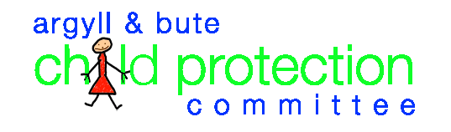
Appendix 1

Multi-agency reflective supervision discussion summary
Date Held
Learning Themes
Agreed Actions
Issues for Escalation
Escalated to
Facilitator
Lead Professional

Appendix 2

Questions to consider at each of the 4 stages of Kolb, D.A. (1984) model of experiential learning.

1 - Concrete Experience:
You consciously and physically experience a situation, which makes you realise that you need to reflect systematically in order to learn something new or improve on your existing skill and practice. Describing what happened? At this stage you are asked to describe the situation and not to make any judgements or draw conclusions. Try to be as detailed as possible, but remain descriptive - just describe what you see, how you feel and what you think.

- What’s has happened or is happening that has brought you to reflect?

2 - Reflective Observation:

What has happened in that situation? What were your reactions and feelings? You are asked to describe your emotional response to the situation you have experienced. Consider what you felt, how your body felt and what you did as well as how the others reacted to your actions. The questions you need to ask yourself are: what worked? What failed? Why did the situation arise? Why did others and I behave the way we did?

- How do you feel about what’s happening?
- How do you think other people are feeling?

3 - Abstract Conceptualisation:
The guiding question for this stage leads on from the questions in the reflective observation stage: what could I have done better or differently? how can I improve? At this stage you are considering the situation and your responses more objectively to make your first value judgements. You are evaluating and analysing what was good or bad about the experience? You should also consider the experience from other people’s perspective in addition to your own. This will help you understand if the situation was positive or negative for you only, or for others too.
At this stage. you try to find different ways for dealing with the situations and think up strategies for when you experience a similar situation again. Also, this is the stage you can also bring in ideas from outside the experience to help you. This could mean involving colleagues and peers in your reflections, but also to consult literature and theories in order to make sense of what happened and get a better understanding and further ideas.

- What is going well, why?
- What is not go well, why?
- Are you feeling or thinking differently about anything now after hearing other people’s views?

4 - Active Experimentation:
In order for you to improve on your practice and learn from specific experiences you need to take this stage particularly seriously. Think about what you can do differently and how you will improve your practice. This stage is now practising the newly acquired theoretical knowledge. You take your collective reflections and thoughts about improvements back into practice and back into the core group to implement any changes required.

- What is the situation now?
- What information is missing?
- How can you find out about these things?
- What is your plan – what actions or updates if any are you taking back to the core group and/or child protection planning meeting?
- What is your contingency plan?

