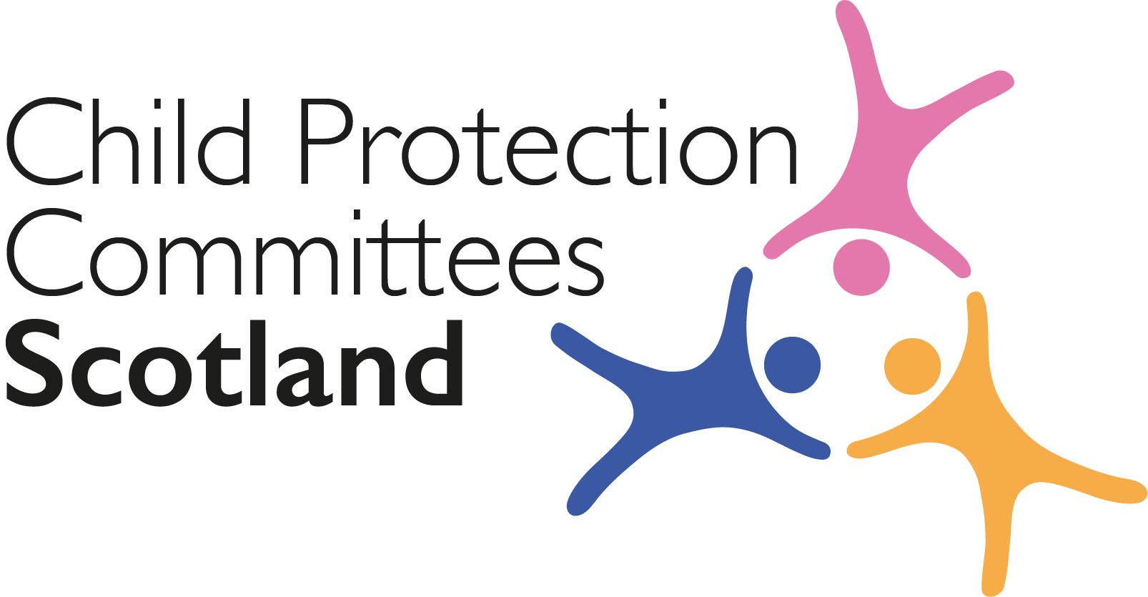
Keeping Connected - The CPCScotland Weekly Bulletin
Issue 47 - Tuesday 9th March 2021

Issued to support Child Protection Committee’s and partners with up to date information on child protection issues.

Welcome to Issue 47 of Keeping Connected.

There is plenty of content to keep us all busy in this week’s Keeping Connected.

I am pleased that we have been able to include a heads up about our next CPCScotland campaign (see item 1) which will focus on Internet safety and which we will deliver as part of a co-ordinated response alongside the Scottish Government CSEthesigns campaign and the Police Scotland ‘Get Help or Get Caught’ campaign. The CPCScotland campaign will focus on parents and carers however we are hopeful that we will be in a position to follow it up with an exciting new campaign targeted at children and young people in the new financial year.

If you have anything from your area that you would be willing to share with colleagues please let us know at cpcscotland-liaison@strath.ac.uk

Keep safe and keep in touch.

Alan Small, Chair Child Protection Committees Scotland

ANNOUNCEMENTS

1 CPCScotland Online Safety Campaign

On 20th March CPCScotland will launch an online safety social media campaign as part of a co-ordinated response alongside the Scottish Government CSEthesigns campaign, which launched on 3rd March, and the Police Scotland ‘Get Help or Get Caught’ campaign. The CPCScotland campaign will run for 10 days and will be directed specifically at parents and carers. An embargoed campaign briefing will be issued to CPCScotland members by close of play on 18th March.

2 Learning Review Community of Practice (Knowledge Hub) Evaluation Final Reminder

CPCScotland and the Care Inspectorate have invited all those eligible to join the Community of Practice to complete a short survey by 12/03/21 to help us evaluate and improve the Learning Review Knowledge Hub platform where the Community of Practice is hosted. The survey should only take about 5 minutes to complete. If you have any technical issues accessing the survey please contact cpcscotland-liaison@strath.ac.uk

Section 1 COVID-19

Guidance, Resources and Information

3 Coronavirus (COVID-19): child contact services guidance

The Scottish Government has published updated guidance to help child contact centres safely re-open their premises and resume face-to-face services during the COVID-19 pandemic.
https://www.gov.scot/publications/coronavirus-covid-19-child-contact-services/

4 Phase 2 of School Return

Scottish First Minister Nicola Sturgeon has confirmed that from 15 March all children in primary four to seven will return to school full-time, and all secondary pupils will return part-time, unless new evidence forces the Scottish Parliament to reconsider - regulated childcare, including breakfast and after-school clubs for primary pupils, will also re-start on this date: https://www.gov.scot/news/phase-2-of-schools-return/

5 CELCIS coronavirus resource page
The CELCIS information online resource rounds up key information, advice and guidance to help anyone supporting the care and protection of children and young people in Scotland during the coronavirus pandemic: https://www.celcis.org/knowledge-bank/covid-19-homepage/

For Children, Families and Communities

6 COVID Vaccination and Pregnancy

An updated leaflet with COVID-19 vaccination advice relating to pregnancy has been published by Health Scotland. This leaflet is available to download in English and in a number of other languages. There is also an easy read version available to download from the website.
http://www.healthscotland.com/documents/37392.aspx

7 New COVID-19 survey on siblings who have a disabled brother or sister

The organisation ‘Sibs’ wants to hear from parents and carers to discover the impact the pandemic is having on siblings up to the age of 18, who have a brother or sister who has special educational needs or disability or a long-term health condition. You can access the survey from a link on the Together Scotland news and events page.
https://www.togetherscotland.org.uk/news-and-events/news/2021/03/new-covid-19-survey-on-siblings-who-have-a-disabled-brother-or-sister/

8 Coronavirus: returning to school – a guide for parents and carers
Promoting Well-Being, a social enterprise, has developed a guide explaining the actions parents and caregivers can take to minimise the risk of Covid-19 virus transmission as children and young people return to school across the UK. The guide also includes advice on supporting children and young people’s mental health and wellbeing.
http://lcukltd.co.uk/wp-content/uploads/2021/03/Promoting-Well-Being_Parent-Carer-Guide.pdf

Research and Evidence Based Reports

9 Social action during the coronavirus pandemic

‘Together We Help’ have published a report on informal social action in response to a crisis. This report brings together learning from across Scotland through survey research, interviews, citizen journalism and creative outputs. The findings, approaches and recommendations emerging from this report will inform the wider Social Action Inquiry planned to start in Spring 2021.
https://socialaction.scot/wp-content/uploads/2021/02/Social-Action-during-the-Coronavirus-Pandemic-Report.pdf

10 Impact of COVID-19 on rural communities in Scotland

New research By National Rural Mental Health Forum and Support in Mind Scotland shows 93% of people living in marginalised rural communities in Scotland have had their mental health and wellbeing impacted by COVID-19. The research focuses on the key issues faced by LGBTQ+ people, young carers, refugees and asylum seekers living in rural Scotland.
https://ruralwellbeing.org/wp-content/uploads/2021/02/Marginalised-Rural-Communities-Support-in-Mind-Scotland-1.1.pdf

11 COVID-19 Early Years Resilience and Impact Survey (CEYRIS) Report 4

Public Health Scotland has published findings from a survey to find out how children in Scotland aged 2–7 years have been affected by the coronavirus pandemic. Findings from the survey carried out in June-July 2020 include: children in poorer households experienced poorer psychological and emotional wellbeing than children in more affluent households; and children in lower-income households, single-adult households and large families took part in fewer home learning activities on a less frequent basis.
https://www.publichealthscotland.scot/media/2934/covid-19-early-years-resilience-and-impact-survey-ceyris-report-4-final-findings-dec2020-english.pdf

12 Covid-19 lockdown: Ethnic differences in children’s self-reported physical activity and the importance of leaving the home environment.

Data from the Born in Bradford research project, monitoring the health of 13,500 children born in the city between 2007 and 2010, shows that one in three children have rarely been leaving the house in lockdown, with only a third of the cohort getting sufficient exercise in the first lockdown.
https://www.medrxiv.org/content/10.1101/2021.02.26.21252543v1

13 Changes in Emotions and Worries During the COVID-19 Pandemic

Adverse psychosocial consequences of the pandemic might be particularly severe for children and adolescents, parents of young children and people with mental health conditions (MHC), who are more prone to the experience of psychosocial stress and who are more dependent on the access to professional psychosocial support. This survey aimed to explore perceived stress and the emotional responses of children and adolescents as well as adults with and without MHC during the social restrictions due to the pandemic.
https://www.careknowledge.com/media/49743/s13034-021-00363-9.pdf

Section 2 Other Child Protection Topics

Guidance, Resources and Information

14 Child Death Review Hub

Information about the National Hub for Reviewing and Learning from the Deaths of Children and Young People is available on the Health Improvement Scotland website. The recently published When a Child or Young Person Dies Guidance (Jan 2021) is also available from this website. The guidance sets out the review process and infrastructure required to support local systems; from the notification of a death to reporting the death, including governance and key elements that make a quality review. It takes account of the need to consider how to keep family and carers at the centre of the process and ensure they are provided with opportunities to be involved in, and informed about, all aspects of the review process.

http://www.healthcareimprovementscotland.org/our_work/governance_and_assurance/deaths_of_children_reviews.aspx
http://www.healthcareimprovementscotland.org/our_work/governance_and_assurance/deaths_of_children_reviews/national_guidance.aspx

15 Fabricated and Induced Illness

The Royal College of Paediatrics and Child Health (RCPCH) has published guidance on perplexing presentations (PP) and fabricated or induced illness (FII) in children. The guidance includes: procedures for safeguarding children who present with PP and FII; practical advice to paediatricians on how to recognise it and assess risk; features of PP and FII including the relationships between parent, doctor and child; and when to refer to children’s social care.
https://childprotection.rcpch.ac.uk/resources/perplexing-presentations-and-fii/

16 Children and Young People’s Mental Health

NSPCC Learning has launched three videos on children and young people’s mental health looking at: how mental health can become a safeguarding concern; the impact of abuse and neglect; and ways professionals can support children and young people who are experiencing issues with their mental health.
https://learning.nspcc.org.uk/child-health-development/child-mental-health

17 Disclosure Scotland: new digital channel to apply for PVG level disclosures

Disclosure Scotland has launched a new digital channel to apply for PVG level disclosures. The new online PVG service will become the main application process for most PVG applications. You can access the service from Disclosure Scotland’s website.
https://www.mygov.scot/apply-for-pvg/?utm_medium=email&utm_source=govdelivery

18 Children’s participation in public decision-making: publish your best practice!

The Centre for Children and Young People’s Participation at the University of Central Lancashire is building an online library of research, evidence and advice developed through participatory projects by and with children. The Centre is asking people to share their examples of best practice.
https://www.togetherscotland.org.uk/news-and-events/news/2021/03/children-s-participation-in-public-decision-making-publish-your-best-practice/

19 Channel and Prevent Multi-Agency Panel (PMAP) Guidance

Channel/PMAP is a Home Office programme which focuses on providing support at an early stage to people who are identified as being vulnerable to being drawn into terrorism. Channel refers to panels operating in England and Wales, while PMAP operates in Scotland.
The programme uses a multi-agency approach to protect vulnerable people by:
- identifying individuals at risk
- assessing the nature and extent of that risk
- developing the most appropriate support plan for the individuals concerned
https://www.gov.uk/government/publications/channel-and-prevent-multi-agency-panel-pmap-guidance

For Children, Families and Communities

20 Child Sexual Exploitation Campaign

Scottish Government are re-running of their CSEthesigns Child Sexual Exploitation Awareness campaign, which was originally launched in 2016. The CSEthesigns campaign will run from 3rd to 24th March on Facebook, Instagram, YouTube and Twitter. The campaign website offers information, advice and additional resources for both parents and young people.
The campaign aims to raise awareness among those aged 11 to 17 and their parents/carers of what constitutes child sexual exploitation, and where they can go for advice and support if they have concerns. It is part of a coordinated response from the Scottish Government, Police Scotland and Child Protection Committees Scotland
http://csethesigns.scot/

Training, Learning Events and Resources

21 ‘What’s happening on the streets with benzos?’
A new, free to access e-learning course on the use of benzodiazepines in Scotland has been launched by the Scottish Drugs Forum. The course has been developed to increase participants’ understanding of the associated harms and escalation of benzodiazepine use in Scotland.
http://www.sdf.org.uk/whats-happening-on-the-streets-with-benzos-free-e-learning-course-aims-to-upskill-workers/

22 Emerging adulthood and transitions from care webinar
CELCIS’s are offering a free online webinar on 24 March from 10:15 - 11:30 am. This will introduce emerging adulthood theory as a social concept and explore and address its implications for Scotland’s care system, and discuss how we can support a better understanding of the development needs of young people and how this theory can support the aspirations of the Independent Care Review's The Promise by enabling more effective implementation of practice and provision. The webinar is designed for practitioners working across foster and residential care, throughcare and aftercare, health, housing and social work, all those who work with and for care experienced young people, particularly those planning or moving through a transition from care to adulthood and interdependence.
https://www.celcis.org/training-and-events/events-pages/emerging-adulthood/

Research and Evidence Based Reports

23The Intergenerational Transmission of Family Violence

Intimate partner violence (IPV) on average affects one in four women and children experiencing parental IPV are now equally understood as victims. Extensive research documents the short‐ and long‐term impacts of children's experiences of IPV on their safety and wellbeing. More recently, research has started to examine adolescent children's use of violence in the home as adolescent family violence (AFV). Contributing to this emerging body of research, this study draws on narrative interview data from mothers who participated in a larger study on IPV, help‐seeking and the perceived impact on children to better understand how mothers make sense of children's use of violence in the home.
https://www.careknowledge.com/media/49742/cfs12830.pdf

24 Mothers' and Children's Experiences of Community‐Based Early Intervention Programmes for Domestic Violence

This article discusses findings from an evaluation of a pioneering early help service in North West England. This new service aimed to improve the safety and wellbeing of families (mothers and children) who were assessed as below the level of ‘high risk’ domestic violence and below the threshold for a child protection order.
https://www.careknowledge.com/media/49744/car2671.pdf

Section 3 News and Opinion

25 In the media

- The Nursing Times has published an article on how the pandemic has affected children and their nurses. The article, which speaks to children’s nurses, health visitors and others, discusses: online appointments; assessing vulnerability; communicating with children; mental health and wellbeing; and health visitors’ workforce.
https://www.nursingtimes.net/news/children/analysis-how-the-pandemic-has-affected-children-and-their-nurses-03-03-2021/
- The Guardian has published two articles about online child protection. The first article reports that the number of men contacting a specialist helpline for people who are watching or considering watching online child sexual abuse material has risen. In 2020, the Stop It Now! helpline handled more than 12,500 calls, emails and live chats from individuals asking for help about their own or others’ online behaviour, compared to 10,700 in 2019. The second article discusses how technology platforms are working to tackle those who pose a threat to children online.
Child abuse hotline reports rise in calls from men viewing illegal content
'It’s an arms race’: the tech teams trying to outpace paedophiles online

26 World Book Day
CELCIS have published a series of three blog posts celebrating World Book Day. Kirsty Capes, author of the upcoming novel ‘Careless’, and marketer at HarperCollins, discusses how her childhood experiences in care led to a career in writing. Callen Martin, Submissions Coordinator at The Good Agency and writer, explains why it’s important for care experienced people to own their stories and why being better represented matters. Finally, Kirsty Hill from the Dolly Parton Foundation UK writes about the Imagination Library and the importance of learning to read for pleasure for children, particularly under-fives.
https://www.celcis.org/knowledge-bank/blog/

27 Online Child Sexual Abuse

Police Scotland have highlighted increasing reports of online child sexual abuse and exploitation. A total of 1,522 child sexual abuse crimes were recorded between April and December 2020, a 13.4% increase on the same period in 2019.
https://www.scotland.police.uk/what-s-happening/news/2021/february/reports-of-online-child-sexual-abuse-and-exploitation-csae-increase-by-13-4/

28 Parental mental health
The NSPCC has released data about contacts to its helpline about parental mental health issues. Between April 2020 and January 2021 the NSPCC helpline received 3,608 contacts from adults about parental mental health. The monthly average has increased by 44% compared with last year.
https://www.nspcc.org.uk/about-us/news-opinion/2021/pandemic-parent-mental-health/

29 Online Safety: Cameras On or Off?

The UK Safer Internet Centre has published a blog in which the Professionals Online Safety Helpline (POSH) discusses considerations around keeping cameras on or off during remote learning with children and young people.
https://www.saferinternet.org.uk/blog/cameras-or-important-questions-answered-posh-helpline

Please feel free to let us know what you think about the bulletin and provide information for inclusion in future editions. Please contact Alan Small or Susan Mitchell at cpcscotland-liaison@strath.ac.uk. Please note that the information included in this bulletin is provided in good faith. Inclusion does not indicate CPCScotland endorsement of the content of the linked documents or websites.

