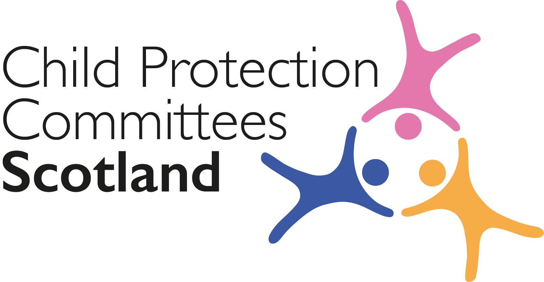
Keeping Connected - The CPCScotland Weekly Bulletin

Issue 56 - Tuesday 11th May 2021

Issued to support Child Protection Committees and partners with up to date information on child protection issues.

Welcome to Issue 56 of Keeping Connected.

Despite the recent weather making it feel more like winter I am sure it will be the school summer holidays before we know it. I would like to highlight to you the advance notice of the school summer holiday campaign being developed on behalf of CPCScotland by the communications sub group (see item 1). Those who have been part of the network for a while will be aware that we have run an ‘Eyes Open’ / ‘Eyes and Ears Open’ campaign at the start of the school summer break for the past 3 years. Last year the campaign was launched early due to the closure of schools during lockdown but this year we expect to be back on track for a launch towards the end of June. As usual we will provide a campaign pack to CPCs and partners and I hope you and your local partner organisations will be able to link with your communications officers / teams and lend your support to the campaign.

Keep safe and keep in touch.

Alan Small, Chair Child Protection Committees Scotland

ANNOUNCEMENTS

1 CPCScotland Summer Holiday Campaign – Advance Notice

The Communications sub group, with support from our Communications Consultant Mairi Damer, are working on refreshed messaging for the 2021 school summer holiday campaign. It is intended to launch the campaign during the week beginning 21st June to coincide with the Scottish schools breaking up for the summer holidays. The campaign will again be primarily delivered via social media with a campaign landing page on our website, but support from local media in your area would also be helpful in spreading the word to the wider public. A campaign toolkit, including an editable press release, will be issued to CPCs and partner agencies in advance to help you to support the campaign. In the meantime please alert your communications colleagues to allow this to be scheduled into your media calendar. For more information contact cpcscotland-liaison@strath.ac.uk.

Guidance, Resources and Information

2 Coronavirus (COVID-19): guidance on summer activities for children and young people
The Scottish Government has published guidance for local authorities on the £15 million of additional funding for the targeted provision of enhanced activities for children, young people and families in the 2021 summer holidays, including how the funding can be used and the Government’s expectations for reporting.
https://www.gov.scot/publications/coronavirus-covid-19-guidance-on-summer-activities-for-children-and-young-people/

3 Child sexual abuse – experiences shared
The Independent Inquiry into Child Sexual Abuse in England, in partnership with the Truth Project, has shared experiences of victims and survivors of child sexual abuse. The experiences, which will be used to inform the inquiry's final report, includes accounts of: barriers to speaking out about abuse; lifelong effects of the abuse; authority figures turning a blind eye; and being ignored, threatened and encouraged to stay silent.
https://www.truthproject.org.uk/experiences-shared

4 Traumatic Bereavement

The UK Trauma Council (UKTC) and three child bereavement charities, Child Bereavement UK, Winston’s Wish and the Childhood Bereavement Network, have launched a new portfolio of free, evidence-based resources for school staff, bereavement services and NHS mental health services, and are appealing for more awareness of childhood traumatic bereavement, particularly in the context of the coronavirus pandemic:
https://uktraumacouncil.org/resources/traumatic-bereavement

5 Safeguarding self-assessment tool
NSPCC Learning has relaunched their safeguarding self-assessment tool for schools and voluntary and community groups. The free self-assessment tool provides: a step-by-step guide to help schools or organisations meet best safeguarding and child protection practices, help to identify areas for development, and support you in making any changes necessary.
https://learning.nspcc.org.uk/safeguarding-self-assessment-tool

6 Cost of school uniforms in England
The Education (Guidance about Costs of School Uniforms) Act 2021, a new law to ensure that state schools in England make cost a priority when setting uniform policies, was passed in the UK Parliament last week after seven years of campaigning. The new legislation is expected to make a significant difference for many families struggling with expensive uniforms.
https://bills.parliament.uk/bills/2615

Training, Learning Events and Resources

7 MARAC Deep Dive events - Reminder

The National MARAC Advisory group is organising a series of deep dive discussions to explore how multi-agency risk assessment for victims of domestic abuse in Scotland can be improved. The full list of these events has now been published. Of particular interest to members may be the session on Children and Young People on Tuesday 22nd June.
Follow the links for more information and to book a place
- Whole System Response / Risk Assessment, Tuesday 25 May 2021
- Information Sharing, Tuesday 1 June 2021
- Collective Leadership and Accountability, Tuesday 8 June 2021
- Training, Tuesday 15 June 2021
- Children and Young People, Tuesday 22 June 2021
- National Guidance / Statutory Footing, Tuesday 29 June 2021
- Intersectionality and Authentic Voice, Tuesday 6 July 2021

8 Working in partnership with families through participative meetings -Reminder
On 26 May at 11:00am, the University of Cardiff is hosting a free online event on international research evidence about shared-decision-making family meetings – involving family members in decision making where there are concerns about a child, rather than key decisions being made in a professionally-led case conference – including a presentation on how two English local authorities have recently expanded the use of such meetings.
https://cardiff.zoom.us/webinar/register/1916164340177/WN_wmsIfsFdQ8ek6EMF1WI9Gg

Children, Families and Communities

9 Latest LockdownLowdown survey

Young Scot, Scottish Youth Parliament and YouthLink Scotland, have launched the next phase of the #LockdownLowdown survey to find out what young people are thinking as we plan to move to the next phase of lockdown https://www.youthlinkscotland.org/news/march-2021/latest-lockdownlowdown-survey-of-young-people-as-restrictions-begin-to-ease/

10 Mental Health Awareness Week 2021: resources

To mark Mental Health Awareness Week from 10-16 May 2021. Mentally Healthy Schools has made available a toolkit of resources for primary and secondary schools. The theme for the week is 'nature' and the toolkit includes some resources about nature and mental health.
https://www.mentallyhealthyschools.org.uk/resources/mental-health-awareness-week-2021-toolkit

Research and Evidence Based Reports

11 Children in Military Families

Angela Ruskin University has published a report, commissioned by the Naval Children’s Charity, examining issues that affect the wellbeing of children in military families including: the impact of deployment-related separation on service children; the impact of mobility; the impact of parental illness, injury or bereavement; and dealing with stigma and bullying.
https://www.navalchildrenscharity.org.uk/wp-content/uploads/2021/05/The-Impact-of-Service-Life-on-the-Military-Child-The-Overlooked-Casualties-of-Conflict-Update-and-Review-Report-Interactive-Singles-1.pdf

Separately, the Service Children’s Progression Alliance has published a a research paper looking at the impact of parental deployment on the wellbeing of British Army children in the pre-school year.
https://www.scipalliance.org/assets/files/Research-Briefing-Paper-Georgina-Normile.pdf

News and Opinion

12 In the media

- The Daily Record has reported on Early Years Scotland’s efforts to keep families and practitioners connected throughout the COVID-19 lockdowns, including through outdoor family play sessions and by sending wellbeing packs with activities and craft supplies and weekly food packs: https://www.dailyrecord.co.uk/special-features/early-years-scotland-keeps-families-23899124

- Investigative journalism co-operative The Ferret has published a feature on the reported sharp increase in child protection investigations across Scotland over the past two years without a corresponding increase in the number of children placed on the child protection register, raising concerns that this could suggest some of the investigations were conducted without due cause:
https://theferret.scot/child-protection-investigations-rose-by-third/

- The Spectator has published an opinion piece by Cristina Odone, head of the family policy unit at the Centre for Social Justice (CSJ), who reflects on what she considers to be Scotland’s ‘emotionally intelligent’ approach to reducing the number of children being taken into care by embedding a trauma aware approach and the Adverse Childhood Experiences (ACEs) model into the education, health, justice and social work sectors – the CSJ recently published a new report on Safely Reducing the Number of Children Going into Care:
https://www.spectator.co.uk/article/scotland-s-inspiring-success-story-with-at-risk-children

- STV News has reported on a young family living on £30 per week as part of a month-long ‘In Their Shoes’ challenge they embarked on to raise awareness of food poverty and teach their young children about this issue:
https://news.stv.tv/east-central/why-our-family-decided-to-live-on-just-30-a-week?top

- The Guardian reports that lawyers have begun judicial review proceedings against the government over allegations it failed to stop children in the UK watching online pornography. Age verification for legal pornography sites was introduced under part 3 of the Digital Economy Act in 2017 but it was never enforced.
https://www.theguardian.com/society/2021/may/05/uk-government-faces-action-over-lack-of-age-checks-on-pornography-websites

Please let us know what you think about the bulletin and provide information for inclusion in future editions. Contact Alan Small or Susan Mitchell at cpcscotland-liaison@strath.ac.uk.
Please note that the information included in this bulletin is provided in good faith. Inclusion does not indicate CPCScotland endorsement of the content of the linked documents or websites.

