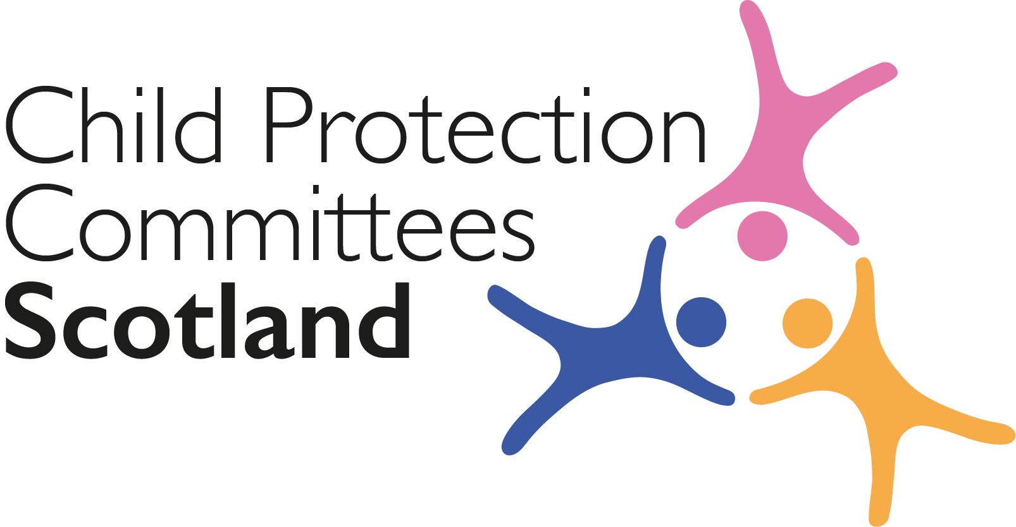
Keeping Connected - The CPCScotland Bulletin

Tuesday 14th June 2022 (Issue 96)

Issued to support Child Protection Committees and partners with up-to-date information on child protection issues.

Welcome to Keeping Connected

I am pleased to let you know that we have managed to rearrange the 4th webinar in the Learning about Neglect series. The final webinar is on 8th September (as we agreed to wait until after the main holiday period is over to maximize the number of people who will be able to attend). In the meantime, thanks to support from CELCIS and our communications and website specialists, we have been able to upload recordings of the first 3 webinars onto the Child Protection Scotland website (links under item 1).

I read with interest the letter signed by 19 organisations including CELCIS and CYCJ calling for all children to be included in the scope of the Bairns’ Hoose model, including those who have caused harm to others (link under item 21). We are lucky to have Val de Souza, Chair of the Bairns’ Hoose Governance Group, leading an input at our CPCScotland meeting later this week and I am sure this issue will form part of the discussion.

Remember if you have anything from your area you think would be of interest to others across Scotland please get in touch with Susan Mitchell at cpcscotland-liaison@strath.ac.uk

Keep safe.

Alan Small CPCScotland Chair

Announcements

1 CPCScotland Neglect Learning Series 2022 – Webinar 4 ‘save the date’

The fourth and final webinar in the 2022 Neglect Learning Series will now take place on 8th September 2022 from 9:30-11am. Please hold the date in your diary if you would like to attend. The speaker for this webinar is Phil Raws from the Children’s Society who will present on Adolescent Neglect.

To receive registration information when it is available click the link below and tick the Child Protection - CPCScotland learning series box towards the end of the list.
Sign up to receive news and updates from CELCIS

For those who did not make it to the 3rd webinar in the series on ‘Addressing Neglect and Enhancing Wellbeing – The role of GIRFEC in responding to the needs of families’ the recording is now online along with recordings of webinars 1 and 2.
Learning About Neglect event series - Thinking Critically About Neglect - webinar no. 1 - Child Protection Scotland
Learning About Neglect Event Series - webinar 2 - Family Group Decision Making for unborn babies and young infants - Child Protection Scotland
Learning About Neglect Event Series - Addressing neglect and enhancing wellbeing - webinar 3 - Child Protection Scotland

2 National Minimum Dataset Version 2 Webinar – Save the Date

Version 2 of the National Minimum Dataset will be launched at CPCScotland on 15th June. Webinars to introduce the dataset, talk through the changes from version 1 and help colleagues think about how it might be introduced will take place on 11th July @ 2pm and 18th August @ 9:30am. More details to follow but please hold the date and time if you are interested in attending.

3 Care Inspectorate Joint Inspection Reports

The Care Inspectorate have published the following reports since March 2022 as part of the Joint Inspection of Services for Children and Young People
- Report of a joint inspection of services for children and young people at risk of harm in North Ayrshire (7th June 2022)
- Second progress review following a joint inspection of services for children and young people in need of care and protection in Orkney (31st May 2022)
- Report of a joint inspection of services for children and young people at risk of harm in West Dunbartonshire (24th May 2022)
Joint inspections of services for children and young people (careinspectorate.com)

Guidance, Resources and Information

4 Social Work caseloads

Social Work Scotland has published ‘Setting the Bar: towards an indicative maximum caseload for Scotland’s public sector social workers’, a new briefing on workforce and workforce planning.
Setting the Bar: towards an indicative maximum caseload for Scotland’s public sector social workers - Social Work Scotland

5 Summary of the national review into the murders of Arthur Labinjo-Hughes and Star Hobson
NSPCC Learning has published a CASPAR briefing summarising the review which looked at the circumstances leading up to the deaths of Arthur Labinjo-Hughes and Star Hobson in 2020. The briefing sets out the background to the review and outlines key findings and national recommendations put forward by the Panel.
The national review into the murders of Arthur Labinjo-Hughes and Star Hobson: CASPAR briefing | NSPCC Learning

6 Child trafficking and modern slavery
The Royal College of Paediatrics and Child Health has published guidance presenting child modern slavery and human trafficking (MSHT) as a significant health concern and addressing the role of paediatricians in relation to MSHT.
Child Modern Slavery and Human Trafficking guidance.pdf (rcpch.ac.uk)
7 Children’s Hearing Advocacy

The Scottish Government has published a progress report on ‘Children's advocacy in children's hearings - national scheme: good practice and issues arising’, which looks at the implementation of the children's hearings advocacy provision in the first year March 2020 to March 2021:
Children's advocacy in children's hearings - national scheme: good practice and issues arising - gov.scot (www.gov.scot)

8 Child and adolescent to parent violence and abuse

CYCJ has published an Information Sheet on Child and adolescent to parent violence and abuse (CAPVA) giving an overview of CAPVA, including responses and approaches.
Info-Sheet-102.pdf (cycj.org.uk)

9 CyberScotland Bulletin

The CyberScotland June Bulletin is now available.
June 2022 – Cyber Scotland

Training, Learning Events and Resources

10 Infant Mental Health Online Learning

The Parent Infant Foundation is hosting a series of events for Infant Mental Health Awareness Week between 14-17 June related to early trauma.
Calendar-2.pdf (parentinfantfoundation.org.uk)

11 Sibling sexual abuse

NSPCC Learning has released a new podcast episode looking at sibling sexual abuse, the impact on children and families and the importance of safety plans. Sibling sexual abuse | NSPCC Learning Podcast - YouTube

12 Safe & Together Model ‘Train the Trainer’

The 2022 Safe & Together’s Train the Trainer will be delivered over 12 weeks from 7 September and until 7 December 2022. Each week is comprised of one 4-hour session of live, remote training with Safe & Together Faculty via Zoom and weekly homework that augments learning and prepares learners for the following week’s sessions. Applications are now being accepted.
For more information contact cpcscotland-liaison@strath.ac.uk

13 Growing Up in Scotland webinar

The ‘Growing Up in Scotland’ conference takes place online on 21 June from 9:30am-1:30pm, and will include an update on the study, presentation of findings from the latest Scottish Government report on Life at Age 14, and presentations from research projects which have recently used the study data. This event is free to attend.
Webinar Registration - Zoom

14 Practical ways to keep you and your family cyber secure (for Public Sector workers)

This free fun and interactive cyber security training is offered to public sector workers from Scottish Union Learning and takes place over 2 sessions on 23rd and 30th June.
June Practical Cyber Resilience Skills (jotfor.ms)

For Children, Young People, Families and Communities

15 Pets and changing homes: the views of care experienced children/young people

Researchers at the University of Edinburgh are looking for the views of care experienced children and young people in a survey of relationships with pets and the impact of housing/home transitions.
Pets and changing homes: the views of care experienced children/young people | The University of Edinburgh

Research and Evidence Based Reports

16 “I Personally Wouldn’t Know Where to Go”

This study aimed to explore perceptions of mental health services from the perspectives of adolescents with no prior service experience.
“I Personally Wouldn’t Know Where to Go”: Adolescents’ Perceptions of Mental Health Services - John Goodwin, Eileen Savage, Aine O’Donovan, 2022 (sagepub.com)

17 Parental Mental Health Problems and the Risk of Child Maltreatment

This is a theoretical review of the risks faced by some children living in families with parental mental health problems and the role that psychotherapy can play in resolving emotional and interpersonal difficulties.
Societies | Free Full-Text | Parental Mental Health Problems and the Risk of Child Maltreatment: The Potential Role of Psychotherapy (mdpi.com)

18 COVID-19 Early Years Resilience and Impact Survey

Public Health Scotland developed the COVID-19 Early Years Resilience and Impact Survey (CEYRIS) to find out about the experience, and impact of COVID-19 and the associated restrictions on our young children in Scotland. From this work, they have published a new briefing paper to summarise their findings.
Overview - COVID-19 Early Years Resilience and Impact Survey (CEYRIS) - COVID-19 and children research - COVID-19 data and intelligence - COVID-19 - Our areas of work - Public Health Scotland

19 Parental participation at Initial Child Protection Case Conferences

This Insight Briefing from Iriss explores the evidence around how parents experience Child Protection Case Conferences and makes reference to the changes in approach within the new National Guidance for Child Protection.
Parental participation at Initial Child Protection Case Conferences | Iriss

20 Poverty and Children in Care
The University of Liverpool has published a study which explores correlations between rising child poverty and children entering care in England.
Child poverty and children entering care in England, 2015–20: a longitudinal ecological study at the local area level - The Lancet Public Health

News and Opinion

21 In the Media

- The BBC reported that the number of children and young people being referred for mental health care in Scotland has risen by 22% since last year.
Children's mental health care referrals up by 22% in Scotland - BBC News

- Third Force News has published a comment piece by Mary Glasgow, Chief Executive of Children 1st, on the recent Scottish Government Spending Review and what it means for children’s services
Tough times make investment in family support essential - TFN

- STV reports that Nicola Sturgeon has suggested that more than £1m in school meal debt accrued by children of families struggling amid the cost-of-living crisis could be written off
Hungry school pupils' £1m lunch debt could be 'written off' suggests Nicola Sturgeon - STV News
- The Ferret reports that critics of the Pause project operating in Dundee have called for some of the rules, which ask for women on the programme to prevent pregnancy by taking contraception or abstaining from sex, to be dropped:
Calls for Dundee women to be offered support with pregnancy 'pause' conditions (theferret.scot)

22 Bairns’ Hoose for all

A number of organisations have written to the Cabinet Secretary for Justice and Veterans, and the Minister for Children and Young People to urge the Scottish Government to work towards the inclusion of all children in the Bairns’ Hoose model, regardless of whether they are child victims, child witnesses or children accused of offending behaviour.
CYCJ supports a 'Bairns Hoose' for all - Children's and Young People's Centre for Justice

23 Resource Spending Review

The Scottish Government has published its latest Resource Spending Review, outlining how over £180 billion will be prioritised in order to tackle child poverty, address the climate crisis and strengthen the public sector as Scotland recovers from the pandemic.
Resource Spending Review - gov.scot (www.gov.scot)

The Guardian has reported that lower priority areas which will see a funding freeze include policing, early years learning and local government:
Scotland to freeze funding on policing and early years education | Scotland | The Guardian

Consultations

24 Funding and Commissioning of Violence Against Women and Girls Services

The Scottish Government is calling for evidence from individuals and organisations to inform the development of a new funding model for services that respond to violence against women and girls in Scotland.
Independent Strategic Review of Funding and Commissioning of Violence Against Women and Girls Services: call for evidence - gov.scot (www.gov.scot)

Recruitment

25 Stop It Now! Scotland

Stop It Now! Scotland are recruiting a full-time communication and fundraising manager and a full time Sexual Abuse Prevention Manager. Closing dates are the 23rd and 24th June respectively.
Jobs in child sexual abuse prevention and child protection - Stop It Now

You can let us know what you think about the bulletin, provide information for inclusion in future editions or request removal from the mailing list. Contact Alan Small or Susan Mitchell at cpcscotland-liaison@strath.ac.uk.

Please note that the information included in this bulletin is provided in good faith. Inclusion does not indicate CPCScotland endorsement of the content of the linked documents or websites.

