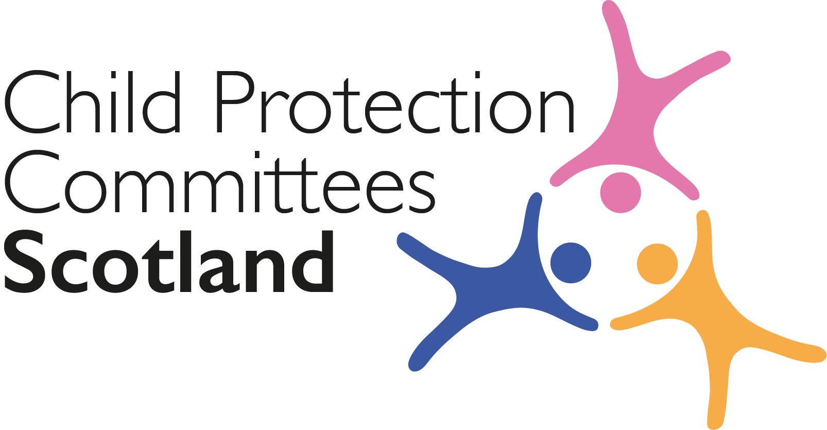
Keeping Connected - The CPCScotland Bulletin

Tuesday 28th June 2022 (Issue 97)

Issued to support Child Protection Committees and partners with up-to-date information on child protection issues.

Welcome to Keeping Connected

This will be the final issue before we break for the summer, and we will be back with a new issue on the 9th August.

The new National Care Service Bill has just recently been published and the future inclusion of children’s services and what shape this will take will be a topic that will occupy us in the consultations to follow.

I would also again draw your attention to the webinars in support of implementation of the National Minimum Dataset version 2 and encourage you to sign up for one of these.

I hope you will all have opportunity to enjoy a break over the summer and look forward to continuing the work with you all in the near future.

Remember if you have anything from your area you think would be of interest to others across Scotland please get in touch with Susan Mitchell at cpcscotland-liaison@strath.ac.uk

Keep safe.

Alan Small CPCScotland Chair

Announcements

1 National Care Service Bill

The Scottish Government has published the National Care Service Bill which provides the foundation for the NCS and will make Scottish Ministers accountable for adult social care; the Bill has provision for children’s social work and care services and justice social work services to be included at a later date, but with any decision on this subject to further evidence, public consultation subject to parliamentary scrutiny and approval - a collection of contextual papers about social care and related areas in Scotland has been published including an overview of children’s social services.
National Care Service Bill published - gov.scot (www.gov.scot)

2 National Minimum Dataset Version 2 Webinar – Save the Date

A further reminder that following the recent input at CPC Scotland on 15th June the Version 2 of the National Minimum Dataset has been launched. Webinars to introduce the dataset, talk through the changes from version 1 and help colleagues think about how it might be introduced will take place on 11th July @ 2pm and 18th August @ 9:30am. More details will follow but please hold the date and time if you are interested in attending.

Guidance, Resources and Information

3 SCIE news

The latest edition of the Social Care Institute for Excellence newsletter is now available and can be accessed at the link below.
Real life impact of COVID-19 responses: Newsletter (scie.org.uk)

4 Scottish Child Abuse Inquiry

The Scottish Child Abuse Inquiry is now taking evidence for its Foster Care case study which includes children who were boarded out, as well as children who were placed in foster care by a Scottish local authority and children who were in kinship care - a woman has told the inquiry of her "horrific" suffering as a child at an Edinburgh foster home.
Woman tells of 'horrific' child abuse at Edinburgh foster home - BBC News

5 Sibling Sexual Abuse
The BBC has released a new File on 4 episode which focuses on sibling sexual abuse in the UK. The episode features families who have experienced this form of abuse and looks at the challenges they have faced. Listen to the episode: Sibling sexual abuse: The last taboo?

Training, Learning Events and Resources

6 United Nations Day of General Discussion – Children’s Rights

The United Nations Committee on the Rights of the Child has published its Outcome Report on the 2021 Day of General Discussion (DGD), which was held in September 2021 on the theme of Children’s Rights and Alternative Care – the report includes the Committee’s recommendations to States, parties, and other stakeholders, based on discussions from the DGD, and CELCIS held the first public opportunity in Scotland to discuss the recommendations on the 22nd June. You can read more about the DGD and the outcome report here.
2021 day of general discussion: Children’s rights and alternative care | OHCHR

7 Understanding Trauma

The Association for Child and Adolescent Mental Health (ACAMH) has released a recording on understanding trauma as part of their ongoing Ask the expert series. The episode discusses how traumatic events can impact a child’s education and how schools can support children who have experienced trauma. Understanding trauma – ask the expert

8 National Joint Investigative Interviewing Project Newsletter

The new National JII Project newsletter has just been published.
The National Joint Investigative Interviewing Project - Newsletter Five .._.pdf

9 United to Prevent Suicide Newsletter

United To Prevent Suicide is Scotland’s social movement for change on suicide. The June newsletter can be read here.
Better Tomorrow Campaign Brief.pdf

10 PANTS Makaton Resource
The NSPCC has created new PANTS resources to keep children who communicate using Makaton safe from sexual abuse. PANTS (the five underwear rules) supports parents and carers to have conversations with their child to help keep them safe from sexual abuse. The resources include Makaton guides explaining the rules and setting out the importance of having these conversations with children.
Working with diverse groups

11 Child Refugees and Trauma

The Association for Child and Adolescent Mental Health (ACAMH) has released a new episode of its podcast in which Professor Panos Vostanis discusses trauma and child refugees as well as approaches to take when working with child and adolescent refugees who have experienced significant trauma.
WACIT; Refugee Mental Health and the Impact of Trauma - ACAMH

For Children, Young People, Families and Communities

12 Edinburgh Schools assist families

Head teachers in Edinburgh have shared the measures schools have taken to help students and their families navigate the cost of living crisis, including providing food parcels, uniform banks and breakfast clubs to ensure no child’s learning is hindered by lack of funds.
Worried Edinburgh schools open canteens to help feed pupils due to cost of living crisis - Edinburgh Live

13 Nurture and Healthy Relationships Improving Outcomes

In an opinion piece for the Scotsman, Joanne Smith, Policy and Public Affairs Manager for NSPCC Scotland argues that securing healthy relationships and nurturing babies and very young children has shown to provide the most efficient and cost-effective way of improving outcomes throughout their lives and meeting the visions outlined in The Promise.
We can't let care for Scotland's vulnerable babies slip - Joanne Smith | The Scotsman

Research and Evidence Based Reports

14 Perceptions of Early Childhood Development

The Royal Foundation Centre for Early Childhood has published the findings of new research into public perceptions of early childhood development – to mark the release of the findings, a roundtable discussion was held with the early years sector, senior government ministers and civil servants to discuss the results and the broader importance of early childhood development to society.
Centre unveils findings of new research into public perceptions of early childhood development - Centre for Early Childhood

15 Whyte Review Into Abuse in British Gymnastics

The Whyte Review has published the final report into mistreatment within British Gymnastics. The review received over 400 submissions. Over 40% described physically abusive behaviour towards gymnasts, primarily during training, which included physical chastisement and inappropriate training on injury. Recommendations include a reform of safeguarding and welfare, complaints handling within British Gymnastics.
About the Whyte Review

16 Fathers and Infants

The Fatherhood Institute has published a report which looks at the treatment of fathers by family services during the first postnatal year. The report discusses the importance of fathers’ physical and mental health to babies’ wellbeing and finds that NHS systems are not set up to engage with, assess, or support new fathers. Read the Nuffield Foundation news story.
Babies let down by post-natal services that ignore fathers

17 Tackling Child Poverty Plan

In response to the Best Start, Bright Futures, the Scottish Government’s second Tackling Child Poverty Delivery Plan, the Joseph Rowntree Foundation and Save the Children have published a report which responds to the plan, giving recommendations to ensure the Scottish Government meets the interim targets. Delivering for families? | JRF

18 Domestic Abuse – International Learning

The DAHLIA-19 international synthesis report is now available on our website. ‘Knowledge to Inform Recovery: Key Messages from Policy and Practice Responses to Domestic Abuse Under COVID-19 Across Four Jurisdictions’ Australia, Ireland, South Africa and the United Kingdom can be read at: Dahlia19+Synthesisreport_June+22++1.pdf (squarespace.com)

19 Learning from Child Deaths

Healthcare Improvement Scotland has published a new report based on a survey in collaboration with Child Bereavement UK, Children’s Hospices Across Scotland and Sands, highlighting the importance of learning from child deaths and keeping the voices of families and carers front and centre in order to gain invaluable insights into what went wrong and where improvements must be made to prevent potentially avoidable deaths of children and young people.
When a child dies - Learning from the experiences of bereaved families and carers: June 2022 (healthcareimprovementscotland.org)

20 Putting UNCRC into Practice
The Observatory of Children’s Human Rights Scotland, 'Matter of Focus' and 'Public Health Scotland' have published ‘The Theory of Change’, the final report from a project funded by the Scottish Government, which brought together experts on children’s rights to work through how the UNCRC can be put into practice and embedded in Scotland.
Observatory projects | The University of Edinburgh
21 Sexting Report
Revealing Reality has released a report, which looks at sexting. The report highlights the extent of the issue and the unequal way it affects young people depending on their gender, socio-economic circumstances and self-perception.
Is sharing nudes just harmless flirting? - Revealing Reality : Revealing Reality
News and Opinion

22 In the Media

- In an opinion piece for the Scotsman, and following the bill laid in Scottish Parliament this week that provides a framework for a National Care Service, Fiona Duncan has said that Scotland’s pace towards keeping The Promise must rapidly increase and there should be no further reason for delays.
Question about whether a National Care Service will keep the promise remains unanswered - Fiona Duncan | The Scotsman

- Bruce Adamson, Scotland's Children’s Commissioner, has warned that the policy to increasingly use “campus cops” risks being a significant barrier to schools being places of nurture and development, increasing the likelihood of children being criminalised and stigmatised. The Scottish Sun reported that almost £2million of a fund earmarked to help the poorest youngsters to do better in schools was instead spent on police officers.
School cops could backfire and worsen kids' problems, warns Scots children's commissioner | The Scottish Sun

- The Sunday Post has revealed that a report from the Competition and Markets Authority (CMA) found that the annual profit of private firms running children’s homes in Scotland is £28,000 profit for every child, with comments on secure care and who provides care in Scotland and an opinion piece from Fiona Duncan from The Promise Oversight Board which calls for action on implementing The Promise.
£28,000 a child: Profit of private companies questioned as the cost of care revealed (sundaypost.com)

- In an opinion piece for the Sunday Post, Claire Telfer, Head of Scotland at Save the Children, has urged the Scottish Government to double the Scottish Child Payment of £20 per week to £40 to help parents offset the impact of the cost of living crisis and avoid more families being pulled into poverty.
Save The Children: Double benefit payment to ease the cost of living crisis (sundaypost.com)

- The Guardian has reported that a new independent review commissioned by Oldham council has found that there was ‘serious failings’ by the police and council that left vulnerable children exposed to sexual exploitation in Oldham, and that there were multiple missed opportunities to prevent abuse stretching back to 2005.
‘Serious failings’ left children exposed to abuse in Oldham, finds damning review | Greater Manchester | The Guardian

- The Herald has reported that social workers and members of the country's largest trade union Unison, which represents thousands of social work staff, have raised concerns about some of the changes which may be implemented by the planned National Care Service (NCS) for Scotland if children’s services are moved into the service, which include proposals to remove child protection services from councils: Alarm raised over consultation to remove child protection services from councils | HeraldScotland

Consultations

23 Physical Intervention in Schools

The Scottish Government has published a consultation on draft guidance, developed with input from young people, parents, carers, education staff and the Children and Young People’s Commissioner for Scotland, on the use of physical intervention in schools.
Use of physical intervention in schools - gov.scot (www.gov.scot)

24 Help tell the UN about children’s rights in Scotland
Together plays a key role in reporting to the UN Committee on the Rights of the Child about Scotland’s progress to implement children’s human rights. They rely on evidence from you to help identify what’s going well and where more needs to be done. This information is used to tell the UN Committee what things are really like ‘on the ground’ for the children and families our members work so hard to support. If you have 10 minutes spare, you can complete the survey to tell about the top three human rights issues for the children, young people and families your support.
Children's Rights Reporting Survey! (surveymonkey.co.uk)

Recruitment
25 Promise Scotland Posts
The Promise Scotland is recruiting for the roles of Chief Executive and independent Non-Executive Directors.
Job Opportunities - The Promise

You can let us know what you think about the bulletin, provide information for inclusion in future editions or request removal from the mailing list. Contact Alan Small or Susan Mitchell at cpcscotland-liaison@strath.ac.uk.

Please note that the information included in this bulletin is provided in good faith. Inclusion does not indicate CPCScotland endorsement of the content of the linked documents or websites.

