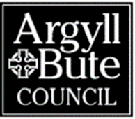
Argyll & Bute Council
Environmental Services,
Kilmory, Lochgilphead, PA31 8RT
Short-Termlets@argyll-bute.gov.uk

CERTIFICATE OF COMPLIANCE
SHORT-TERM LETS LICENCE – CONFIRMATION OF DISPLAY OF PUBLIC NOTICE
The Civic Government (Scotland) Act 1982 (Licensing of Short-term Lets) Order 2022

CONFIRMATION OF DISPLAY OF NOTICE

This section must be completed by the applicant and the whole notice returned to the Licensing Authority at the above address at the end of the 21 - day display period. Alternatively please provide confirmation of display in writing with signature, along with full applicant and property details.

I (Full name of applicant)
Certify that the notice of application has been displayed as prescribed above for a
period of not less than 21 days from _____________ ending on
_______________

Applicant’s signature |  | Date

