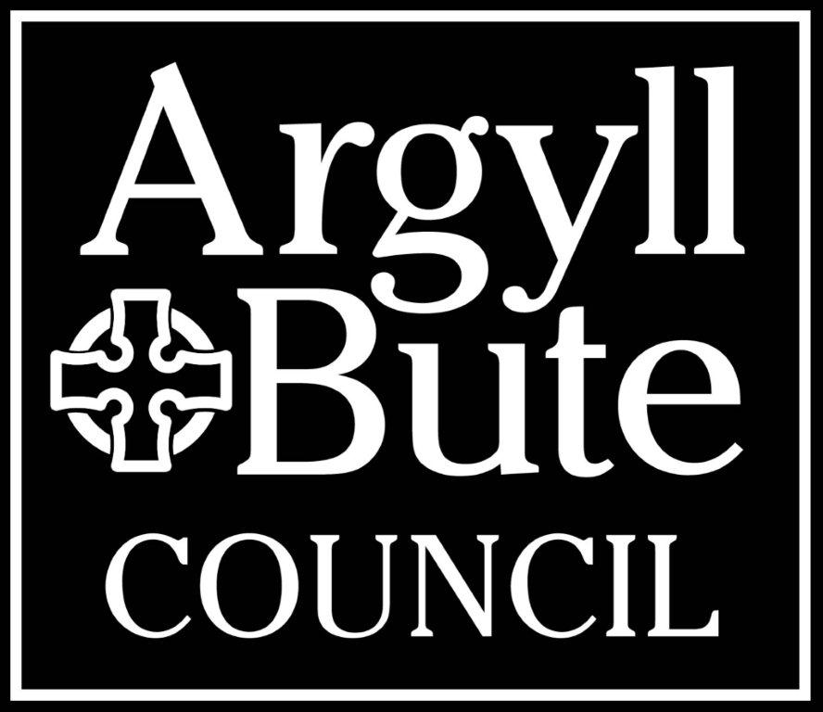
Name___________________________________________

Subject Address___________________________________

________________________________________________

________________________________________________

Council Tax Reference Number_______________________

Contact Number___________________________________

Email Address_____________________________________

COUNCIL TAX DISCOUNT APPLICATION - SEVERELY MENTALLY IMPAIRED

Dear Sir/Madam

The Council Tax due on a property may be discounted to reflect the personal circumstances of the adult residents. Such a reduction will apply where less than two adults are resident in the property. For the purpose of the reduction adults who meet the undernoted qualifying conditions shall be disregarded when counting the number of adults in the house.

If you want to apply for discount please complete the form overleaf, attach any confirmation of income etc, sign the declaration and return the form to the address shown below.

QUALIFYING CONDITIONS: SEVERELY MENTALLY IMPAIRED

A person who has an apparently permanent severe impairment of intelligence and social functioning, as certified by a registered medical practitioner, and who is receiving one or more of the following state benefits:

1. Incapacity Benefit
2. Employment Support Allowance
3. Attendance Allowance
4. Severe Disablement Allowance
5. The highest or middle rate care component of Disability Living Allowance(DLA)
6. Enhanced Rate of daily living component of Personal Independence Payment (PIP)
7. An increased rate of Disablement Pension
8. Disabled Person's Tax Credit
9. Unemployability Supplement
10. Constant Attendance Allowance under the Personal Injuries (Civilians) Scheme or the Naval, Military and
Air Forces etc, (Disablement & Death) Service Pension Order
11. An Unemployability Allowance under the legislation in 8 above
12. Income support which includes a disability premium
13. Universal Credit - Limited Capability for Work and Work Related Activity or Limited Capability for work
14. Adult Disability Payment (Daily Living Part)

Evidence required that MUST be provided in support of your claim

LETTER FROM BENEFITS AGENCY AND/OR A COPY OF YOUR AWARD CERTIFICATE DETAILING BENEFIT ENTITLEMENT AND THE DATES BENEFIT COMMENCED
FAILURE TO SUPPLY SUCH EVIDENCE COULD DELAY IN THE PROCESSING OF YOUR CLAIM

Data Protection Fair Processing Notice: Argyll and Bute Council, will primarily use the information you have supplied on this form for the collection and administration of Council Tax. You have a statutory duty to provide the information. The level of Council Tax charged must be accurate and the Council will use information from other agencies to check liability for Council Tax and minimise fraud and error where it is necessary to do so. We share information with other sections of the Council and other organisations external to the Council where it is lawful to do so. A full privacy notice is available at https://www.argyll-bute.gov.uk/privacy/council-tax.You have a right to apply for a copy of the information we hold about you, and to have any inaccuracies corrected. Should you wish to exercise this right, your request must be made in writing to the Data Protection Officer, Argyll & Bute Council, Kilmory, Lochgilphead, PA31 8RT, mail iain.jackson@argyll-bute.gov.uk or telephone 01546 604188.

DISCOUNT: SEVERELY MENTALLY IMPAIRED – Council Tax Reference Number_________________

SECTION 1: TO BE COMPLETED BY A LIABLE PERSON

I apply for discount on the basis that:

(Name) _________________________________________________________

meets the qualifying conditions noted overleaf.

The benefit received by this person is ______________________________________________________

and I enclose evidence of this e.g. photocopy of front cover and first page of benefit order book, or letter of entitlement to the benefit.

The number of adults (including the above named) usually resident in the house is

SECTION 2: TO BE COMPLETED BY A REGISTERED MEDICAL PRACTITIONER

I confirm that in my opinion the above person suffers from a severe impairment of intelligence and social functioning which appears to be permanent.

To my knowledge this condition has existed since _____/_____/_____

Please give a description of the nature of the impairment and medical term :-

Medical Practice Stamp

Signed: _________________________

Position: _________________________

Date: ________/________/________

DECLARATION

I declare that the information on this form is true and complete and I authorise Argyll & Bute Council to verify the details.

I will notify within 21 days any change in circumstances which may affect my liability e.g. discount status no longer applies to the person named in Section 1, or the number of adults in the house increases.

I understand that failure to provide this information is an offence which may make me liable to an initial fine of £50 and £200 for each subsequent offence.

Signature of
Liable Person: _____________________________________ Date: _____/_____/_____

