

Please find below a brief update on various key areas of work. These briefings are also available for reference as part of the various information resources available on the new Member Zone system

**Roads and Infrastructure**

**Weekly member briefing**

**Edition 65 – 2nd September**

Please let us know if you find these briefings useful and if there is any specific information you would like or alterations to the format.

The updates are designed as a resource for you to be able to answer constituent queries.

You can find details of notable service disruptions on key service areas like bin collections and street lighting on the Council website here

As well as the updates on notable roads schemes in the table below, the whole roads capital programme is available online – you can access the full list of schemes [here.](https://www.argyll-bute.gov.uk/roads-capital-programme-0)

|  |  |  |  |  |
| --- | --- | --- | --- | --- |
| **Oban, Lorn and the Isles** | **Helensburgh and Lomond** | **Mid-Argyll, Kintyre and the Islands** | **Bute and Cowal** | **All areas** |
| **Notable road schemes**  Surfacing work through Soroba Road in Oban, which has been carried out via nightshift to minimise disruption, is on schedule to complete by the weekend.  The next major scheme is surfacing work on Coll which will begin next Monday, 12th September.  **Bus services**  We are continuing to work with colleagues at West Coast Motors to review the community feedback on the recent changes to the bus services in Oban and surrounding areas. We are hopeful that we will be able to provide a detailed update which will include further bus service changes next week. This should go some way to addressing many of the concerns raised as well as retaining the enhancements to the service which has been provided for the Dunbeg community.  This will be provided to OLI members in advance of wider issue. | **Notable roads schemes**  Surfacing work has begun at Whistlefield this week and is expected to complete around the middle of next week.  **A814 Ardmay rockfall**  This work continues to its revised schedule and we expect it to be completed by Monday 5th September.  **Howie Park**  The redundant streetlighting columns at Howie Park have now been removed and the connections isolated.  **A814 Glen Mallan proposed road closure**  The MoD have now informed us that the works which would have required road closure – safe loading and unloading of munitions at Glen Mallan – have been postponed. | **Notable roads schemes**  The significant schemes at Glenrallach and Inverneil on the B8024 are ongoing.  Surfacing work continues at Scalasaig on Colonsay, this has been delayed slightly and is now scheduled to complete at the end of next week  **Jura Ferry**  Following successful trials with the crew on the Eilean Dhiura our candidate will now begin the process that will see orientation and familiarisation as well as technical courses to ensure full competence and compliance with MCA requirements.  This process is moving along well and we expect to have the position filled by early October.  **Campbeltown Flood Scheme**  Thank you to those that attended the engagement event on Wednesday 31st August in Campbeltown.  The member briefing and public pop-up sessions went very well and helped provide a background to the scheme, explain the processes, the community benefits and how the contractor will aim to minimise disruption.  Work will officially start onsite this Monday, 5th September, with the contractor beginning to construct their site compound off Hillside Road. A letter drop has been issued to local residents to advise them of the works and where and how to get more information.  A detailed information pack with presentation slides, letters issued and outline communications plan etc. will be issued early next week.  All project documentation and communications will be stored online on the dedicated [webpage.](https://www.argyll-bute.gov.uk/campbeltown-flood-protection-scheme) | **Notable roads schemes**  Work is still ongoing with the road widening either side of Meckan’s Grave on the A8003;  The surfacing programme noted in last week’s update has commenced on the A844 Victoria Street in Rothesay and West Pier/B881 High Street.  **Rothesay pontoons**  The Principal Contractor, Teignmouth Maritime Services, has installed the pontoon system, piles and access gangway.  A specialist subcontractor, Gael Force Engineering, has installed utilities for the berthing facility and the secure access fencing.  At present we are waiting on some snagging items prior to opening the facility to the public.  **Rothesay Harbour lift**  A detailed briefing was issued to local members earlier this week in the form of an FAQ-type document  We hope you found this useful.  The main headline from that briefing is that we expect further works to commence this Tuesday, 6th September. .  **A886 Leanach landslip**  The contractors are on site and have begun constructing the temporary road that will allow the work force to work safely as they build a retaining wall which will address the slope stability issues. | **Parking review**  Technology is bringing new opportunities for managing parking, and supporting the diverse needs of local communities, businesses, and visitors for parking.  We are always keen to explore new ways of working if they could have a benefit for the area and so are seeking views on parking and how technology might support local needs.  We are working with AECOM, experts in developing parking policy. Responses to the survey will go to AECOM for analysis.  We will then be in a position to introduce technology solutions, in line with local area needs, and as funding becomes available.  The survey is available [here.](https://www.argyll-bute.gov.uk/consultations/parking-review) |

: 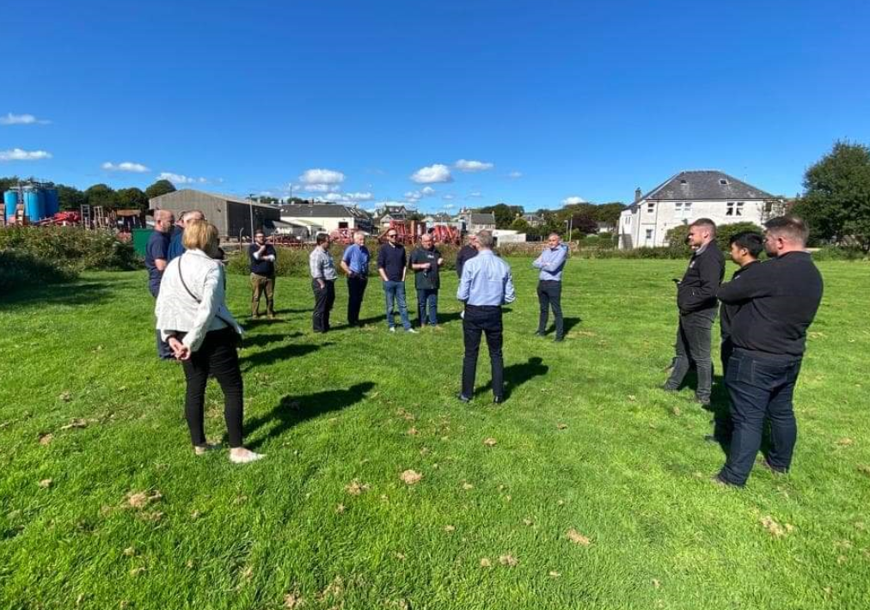

Council Officers and Elected Members meeting with design consultants AECOM and contractor DAWSON WAM on site. This picture was taken in the Meadows area where three new flood attenuation ponds will be created as part of a wider £15million package of flood prevention measures.

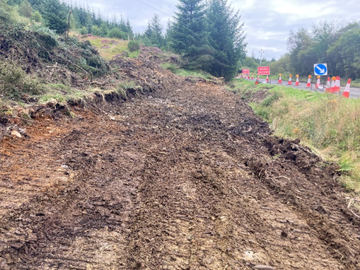

Preparation works for the temporary road on the A886 that will allow for safe working while the new retaining wall is constructed.

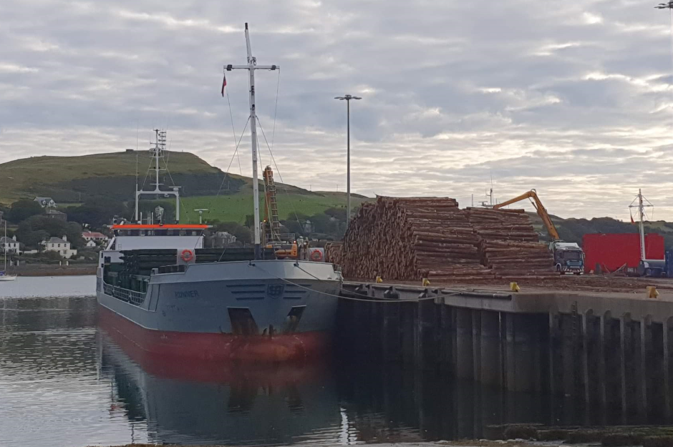

This is an image of timber piled and waiting to be loaded in Campbeltown. This is a key industry for Argyll and Bute which is supported via our local marine team in Campbeltown.