

Please find below a brief update on various key areas of work.

**Roads and Infrastructure**

**Weekly member briefing**

**Edition 92: 6th April**

Please let us know if you find these briefings useful and if there is any specific information you would like or alterations to the format.

The updates are designed as a resource for you to be able to answer constituent queries.

You can find details of notable service disruptions on key service areas like bin collections and street lighting on the Council website here.

As well as the updates on notable roads and footway schemes in the table below, the whole roads and footway capital programmes are available online – you can access the full list of schemes [here.](https://www.argyll-bute.gov.uk/roadworks)

You can view all member briefings on the [website](https://www.argyll-bute.gov.uk/ris-member-briefing)

|  |  |  |  |  |
| --- | --- | --- | --- | --- |
| **Oban, Lorn and the Isles** | **Helensburgh and Lomond** | **Mid-Argyll, Kintyre and the Islands** | **Bute and Cowal** | **All areas** |
| **Streetlighting**  SSE in are attendance at Lynn road and Soroba Road in Oban this week repairing underground cabling fault and replacing distribution units.    **Pennyfuir cemetery**  Footway improvement works at Pennyfuir cemetery are now complete | **Roads**  The team are currently making arrangements to commence pre surface dressing schemes in Helensburgh and Rhu.  Over the next couple of weeks pre surface dressing will take place on  - Cumberland Avenue  - Kidston Drive  - Lineside walk (Rhu)  - B833 Mill Brae (Rosneath)  - Red Road (Cardross)  - Darleith Road (Cardross)  - Old A82 Luss  This work is part of the surface dressing schemes scheduled to Helensburgh and Lomond  **Streetlighting**  We have secure contractor assistance to carry out required work at West Rossdhu Srive, Abercombie Street (which is affecting numerous streets) and the Succoth Houses in Arrochar.  The required tracking (underground cabling) work to ensure the lights are operational again should be completed by the end of the month | **Fly tipping**  A report was received of approx. 2 tonne of fly tipping across the road from the former Putechan Hotel in Kintyre  We have been liaising with SEPA and Police Scotland on this matter and have been successful in identifying the person allegedly involved and a penalty notice has been issued and accepted.  The waste has been removed from the shore side and the offender is making arrangements for an uplift, SEPA will continue to monitor to ensure it is disposed of correctly. Landowners are generally responsible to remove fly tipping from third party land. The collaborative work of SEPA, Police Scotland and the Council has resulted in a positive early resolution for this site.  **Campbeltown Harbour**  Yachts and cruise boats have started to arrive and travel from the pontoons and berths as the sailing season gets underway.  **Recycling collections**  Due to ongoing operational issues with our refuse vehicle there have been a number of disruptions to both the general waste and recycling waste collections across mid Argyll this week.  To enable us to catch up with the general waste collections, which are the priority we have had to make the decision to delay any recycling collections until the next scheduled collection date.  A disruption has been placed on the website and a ‘[keep me in the loop’](https://argyllandbute.custhelp.com/app/admin/Contact_Preferences?utm_source=council%20website&utm_medium=banner%2C%20homepage%20link&utm_campaign=customer%20outreach) email will be issued to  those signed up to the service | **Road sign replacement**  The team have been replacing directional road across Bute and Cowal. This is part of the additional investment made by Council for replacement of road signs.  **Rothesay harbour toilet facilities**  The facilities at the Victoriana Public Conveniences remain available to all visitors and residents.  Over the winter months we closed the showering facilities at 18:00, when closing the toilets. The available hours will be extended going into the Easter weekend and thereafter throughout the sailing/tourist season.  The amended opening times will be 8am – 8pm ready for the opening of the new pontoons on Easter Friday.  **Bute Resilience Easter event**  Following last week’s update we are pleased that officers have been able to assist in processing the application through at such short notice and the event will go ahead on Saturday at the event space off Montague Street Rothesay.  **Glendaruel bridge**  The bridge was closed on Wednesday 5th April to allow for resurfacing works on the bridge. These works have been carried out to repair some damage caused by vehicles heavier than the bridge’s carrying capacity. Physical restrictions have been placed on site to prevent heavy vehicles form using this restricted bridge. | **Refuse collections**  Refuse collections will operate as normal over the Easter public holiday    **Capital programme**  We are currently in the process of preparing the programming of plant, materials and labour together with registering each scheme on the national roadworks co-ordination system for the £8m capital investment in roads reconstruction across all areas. The full programme will be available on the Website as works get underway later this month.  **Electric Vehicle Chargers**  We are progressing the Warranty and Maintenance invitation to tender with procurement and are addressing each adhoc quote as they come through for those units out of contract.  We currently have 7 faults within the network, users can get real time updates via [ChargePlace Scotland | Scotland's Public EV Charging Network](https://chargeplacescotland.org/)  **Marine Activity**  With the Crinal Canal open this week following various works to improve and maintain the canal. We are seeing a steady number of vessels travelling as we approach the Easter weekend. Several yachts have visited the pontoons in Oban. The photo below shows the boutique cruise ships who sail from Oban preparing for guests joining them for excursions. |

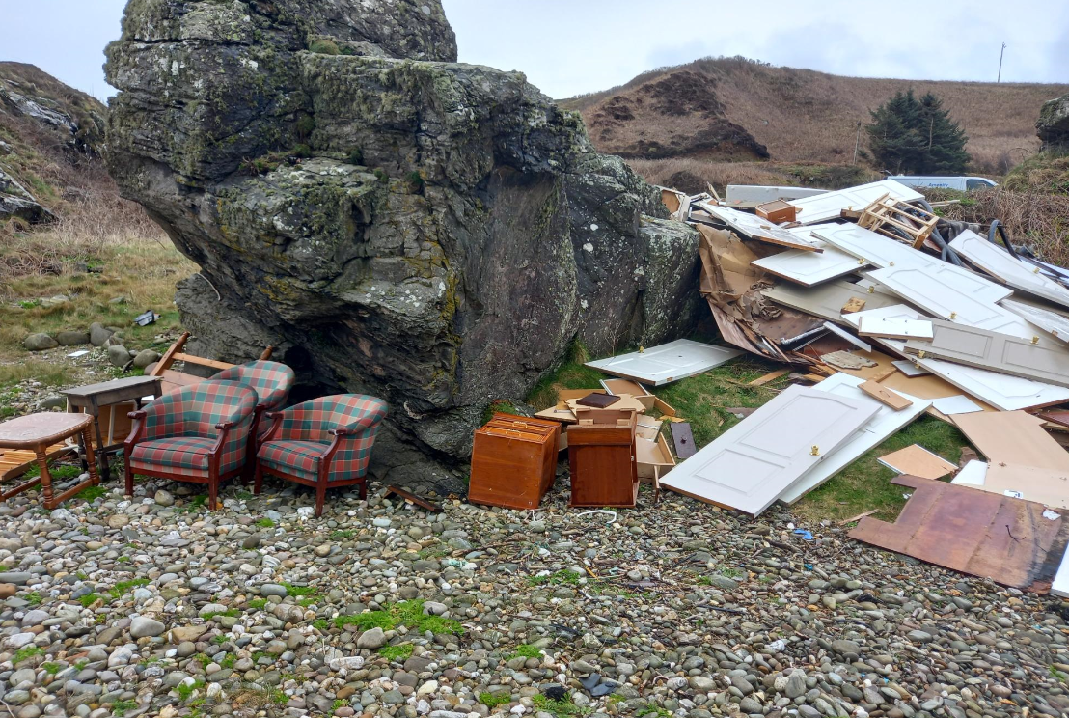

The Boutique cruise ship in Oban this week

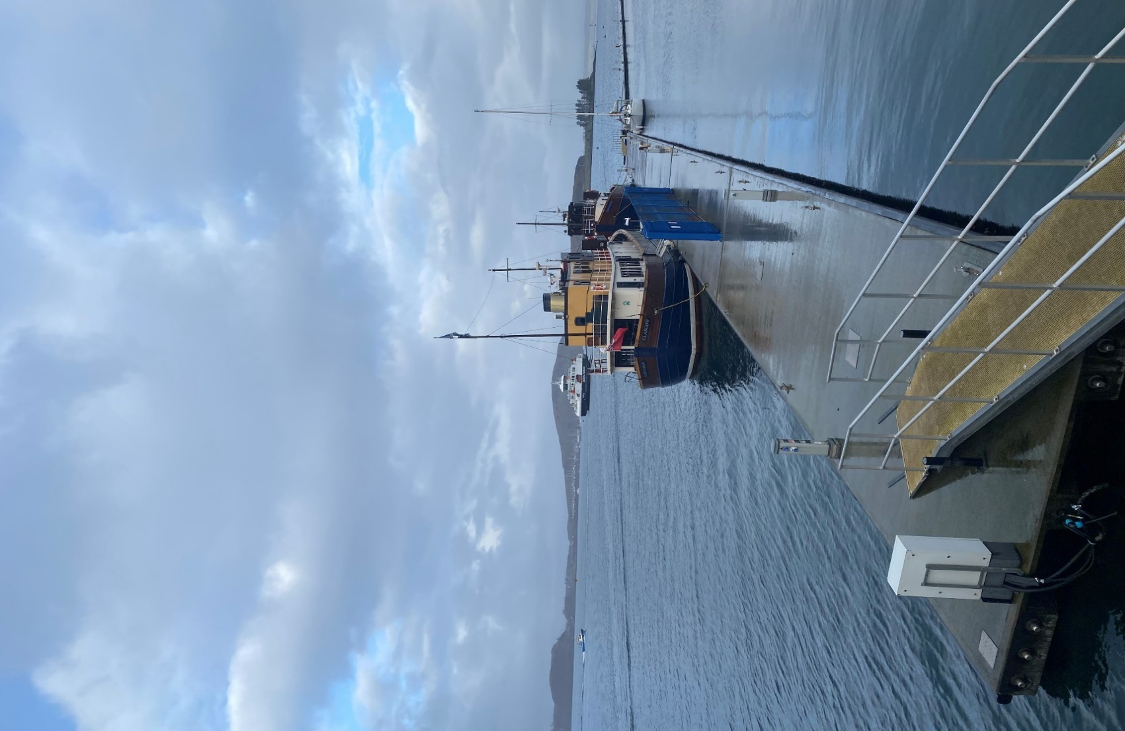



The incident of fly tipping reported in Kintyre this week