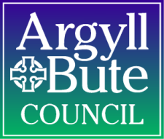

Argyll & Bute Council
Psychological Service

Consultation Form

Section 1 and 2 should be completed when it has been agreed through discussion with the psychologist that a formal consultation meeting should take place. It should be given to the educational psychologist in advance of the meeting. Parental agreement should be obtained prior to the consultation.

Section 1

Educational Psychologist

School:

Pupil details

Name:

Date of birth:

Age:

Sex:

Position in family:

Parents/Carers:

Address:

Tel:

Languages of the home:

Other agencies involved:

Section 2

What are your main concerns?

What strategies have already been tried regarding your concern and how effective have these been?

What are the child’s strengths and interests?

What do you hope to achieve through this consultation meeting?

Date parental permission sought:
Section 2 should be reviewed at the consultation meeting to allow those present to contribute any further information. Sections 3, 4 and 5 should be completed at the consultation meeting.

Section 3

How would you like things to change?

What other information would it be helpful to discuss?

Section 4

Summary and conclusions

Section 5

Outcome of Consultation

Strategies/Actions/Agreements | To be carried out by

Present:

Date of consultation meeting:

