Marvellous Me:

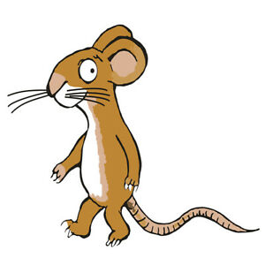

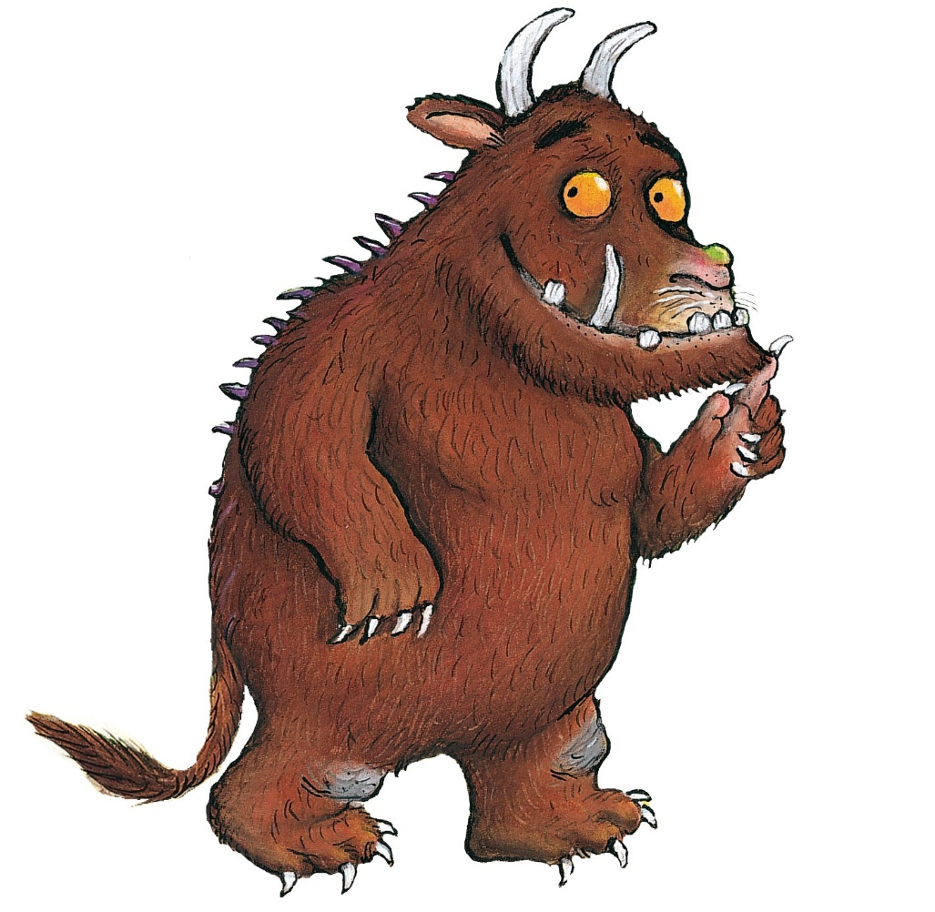

All set for Primary 1

(Article 28, UNCRC, 1989)

This is me ☺ (please draw or add a photo)

My name is: ______________________________________________________________________

I’d like you to call me (Article 12, UNCRC):

________________________________________________________________________________

Here I am with my family (please draw or add photo):

I live with: _________________________________________________

My pets are: _________________________________________________

Other important people in my life are:

________________________________________________________________________________

­­­­­­­­­­­­What are your hopes and aims for yourself as you go to school?

________________________________________________________________________________

What do your family hope and aim for you going to school? _______________________________________________________________________________

________________________________________________________________________________

________________________________________________________________________________

Is there anything your family would like to share with the school about you?

_______________________________________________________________________________

________________________________________________________________________________

________________________________________________________________________________

I have a special friend called: _________________________________________

My favourite TV programmes are: ______________________________________

Some favourite places I like to visit are: _________________________________

Favourite foods and drinks are: _______________________________________

Things that make me sad are: _________________________________________

When I am upset I need: ____________________________________________

I am frightened by: _______________________________________________

I am happy when: _________________________________________________

**What I have learned so far? (please circle)**

I can look after myself by brushing my teeth. Yes No

I can look after myself by washing my face. Yes No

I can look after myself by washing my hands. Yes No

When I need the toilet I say: ________________________________________________________

Sometimes I may need help with: ­­____________________________________________________

Any other information that makes me, me (describe my personality so far):

_______________________________________________________________________________

________________________________________________________________________________

I enjoy looking at books, my favourite is: ________________________________

When I am speaking people understand what I am saying. (please circle)

Mostly Sometimes Not Really

I can follow simple instructions. (please circle)

Mostly Sometimes Not Really

Can you draw a picture of yourself? (Which hand did you use? Please circle) RH LH Both

I can recognise and name some colours: ______________________________________________

________________________________________________________________________________

I can recognise some shapes: _______________________________________________________

________________________________________________________________________________

I am becoming aware of some numbers and counting (please circle). YES NO

I have a special interest in: _______________________________________________________________________________

________________________________________________________________________________

________________________________________________________________________________

**My Lockdown experience:**

The best things about staying at home for a long time were:

Things that were not so good for me:

