

Please find below a brief update on various key areas of work.

**Roads and Infrastructure**

**Weekly member briefing**

**Edition 108 : 28th July**

Please let us know if you find these briefings useful and if there is any specific information you would like or alterations to the format.

The updates are designed as a resource for you to be able to answer constituent queries.

You can find details of notable service disruptions on key service areas like bin collections and street lighting on the Council website [here.](https://www.argyll-bute.gov.uk/roads-and-travel/status)

You can view all member briefings on the [website](https://www.argyll-bute.gov.uk/ris-member-briefing)

|  |  |  |  |  |
| --- | --- | --- | --- | --- |
| **Oban, Lorn and the Isles** | **Helensburgh and Lomond** | **Mid-Argyll, Kintyre and the Islands** | **Bute and Cowal** | **All areas** |
| **Roads updates**  Capital footway works on Miller Road have now completed (images below)  Dunollie footway improvements are ongoing and will continue in to next week.  The team will also be carrying out some surfacing work at Appin Primary School on behalf of our colleagues in Education  **Mull bin collections**  Due to a vehicle breakdown there have been a number of disruptions to the collection of recycling bins on Mull this week.  Crews have been working hard all week and will do so over the weekend to ensure collections are caught up | **Roads updates**  Capital inlay scheme to the value of £37,000 will commence on Monday 31st July on School Road, Rhu.  The work is expected to last around five days.  **Faulty traffic lights**  The permanent traffic lights on the junction of Sinclair Street and Princes Street have been temporarily turned off to assist Scottish Water in repairing a burst mains water pipe.  Temporary four way lights are in position, we are aware these malfunctioned this week. The contractor attended and repaired however the contractor now has an operative on site manually controlling them during working hours.  **Lining work**  We are liaising with the lining contractor to secure a return date in August to carry out any outstanding lining work | **Roads updates**  Surfacing work scheduled to commence on the A816 at Barrichbeyan bends 8th Aug  The £226,000 surface dressing scheme on Ormsary Hill has now completed  **Islay School and Public Transport Survey**  Our contract for providing school and public transport (service no 450 & 451) ends in November 2023.  There is an online survey running until the 28th August which can be found [here](https://www.argyll-bute.gov.uk/my-community/community-planning/consultations/consultation/islay-school-and-public-transport-0). All responses are anonymous | **Roads updates**  Capital footway improvements work is ongoing on St Brides road and Blain Terrace on Bute.  Capital footway works in Cowal are ongoing, improvement works included are on Ardenslate road, A885 Argyll Street and Bencorrum Brae.  The team will also be moving to the footways on Clyde Street, Kirn next week  Surface dressing on the A886 Rhubodack and the B881 Meikle Grenach will complete today  **Westlands household waste recycling centre**  A reminder that essential resurfacing work has been scheduled to commence week commencing Monday 7th August at Westlands civic amenity site.  Site capacity will be reduced between the 7th and 17th August. We are requesting that domestic / non domestic vans and trailers try not to visit the site which will allow Renewi to keep the disruption to a minimum, |  |

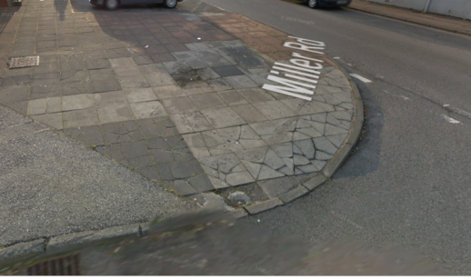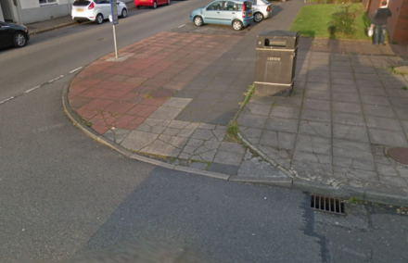

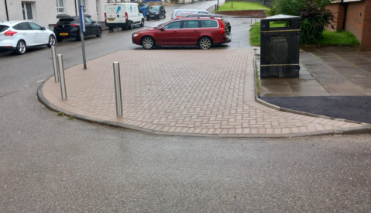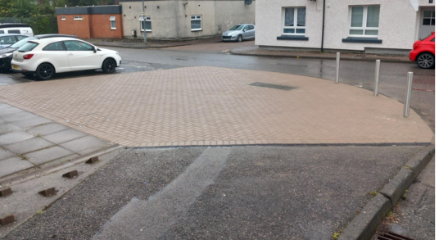

Before and after pictures showing the footway improvement work on Miller Road, Oban