| Tick  One  Box | **For Information Only** | **For Decision Only** | | **For Discussion** | |
| --- | --- | --- | --- | --- | --- |
|  |  | | **X** | |
|  | | | | | |
| **ARGYLL AND BUTE COUNCIL** | | | **D&I DMT** | |
| **CUSTOMER SUPPORT SERVICE** | | | **29th January 2024** | |
| **Member Zone Update Report FQ3 2023-24** | | | | |
|  | | | | |

1. **0 INTRODUCTION**
   1. This report forms part of the ongoing monitoring of the request and information management service provided to elected members by Services via the Member Zone system. The report details service request activity in FQ3 2023-24 and since MZ’s inception in June 2022. It also covers the work of the MZ Sounding Board of officers and members, which had its fifth meeting in October 2023 (See Minute at Appendix 1.) and the informational and system developments implemented over the past quarter that were sanctioned by the Sounding Board.
   2. In summary in FQ3 2023/24:

* Members logged 253 new requests, taking the total to 1856 since inception in June 2022. This was a slight decrease over the 305 requests made in the previous quarter (fewer over Christmas holidays) and of these 23% were for services other than Roads and Infrastructure Services.
* 292 requests were actioned by Services, so the live caseload with Services for action reduced by 39 over the quarter. Of the 163 requests in action at the end of the quarter, 16 were past their response SLA by over a week, 11 of these for RIS. 377 requests were closed by members, 245 of these closed by the member and 132 by the 12 week inactivity auto closure functionality.
* Members are able to complete a survey on timeliness and quality of response and since this function launched, 126 timeliness surveys were completed with 118 (94%) scoring moderately to very happy with timeliness of response. In FQ3 47 surveys were completed and 45 (96%) scored moderately to very happy with timeliness of response. 137 quality of response surveys have been completed since inception and 127 (93%) scored 3 or higher out of a 5-point scale. In FQ3 47 surveys were completed for quality and 44 (94%) scored them 3 or higher.
* The Digital Service Team have developed and released another tranche of system improvements that the Sounding Board mandated at the fifth Sounding Board in October (Appendix 1), or through member requests. A new Councillor, Jennifer Kelly was added to MZ replacing the previous Councillor Donald Kelly.

1. **0 RECOMMENDATIONS**

2.1 We recommend that DMT:

* Note the performance of the teams supporting the MZ system over the past FQ3 quarter and since launch.
* Note the ongoing work to enhance the system and associated resources so that it meets the needs of members.
* Agree to send the report to ELT so that they can note the MZ related activity.

**3.0 DETAIL**

* 1. A key element of the Member Zone is the request management system that allows members to make requests for action and information from Services and for both the members and Services to manage their caseloads effectively. The table below summarises the key performance metrics of that system since inception and for the FQ3 2023-24 period:

| **Since Inception** | **RIS Requests** | **Other Services** | **Total** |
| --- | --- | --- | --- |
| **Total Requests Made** | **1441 (78%)** | **415 (22%)** | **1856** |
| **Requests in Action\*** | **130** | **33** | **163** |
| **Requests Actioned by Services** | **1311** | **382** | **1693** |
| **Requests Closed by Members** | **925** | **288** | **1213** |
| **Open with Members** | **386** | **89** | **475** |
| **Open and Escalated** | **0** | **5** | **5** |
| **Activity in FQ3: (figures in brackets are FQ2 comparators)** | **RIS Requests** | **Other Services** | **Total** |
| **New Requests** | **195 (209)** | **58 (96)** | **253 (305)** |
| **Requests Actioned by Services** | **253 (211)** | **42 (82)** | **292 (293)** |
| **Requests Closed by Members** | **304 (110)** | **73 (66)** | **377 (176)** |
| **Overdue >1 Week at end of period** | **11 (2)** | **5 (4)** | **16 (6)** |

*Includes those requests awaiting response, escalated and where Services have scheduled work for completion at a future date.

3.2 There was a decrease in the number of requests made in FQ3 compared to the previous quarter; down from 305 to 253 requests, however FQ3 includes the quieter Christmas quarter and member refrained from posting lower urgency requests during the October storms. The previous split had been 69% RIS enquiries and 31% for other Services, however last quarter that split was 77% RIS and 23% other Services. Perhaps reflecting the higher number of weather related activity. Overall the live caseload of ‘In Action’ requests at quarter end was 163, with only 16 of these past their SLA by more than a week, so the caseload appears to be well managed and 292 requests were cleared by Services compared to 253 being raised. Of the 1856 requests logged since inception, 1477 (77%) were raised using self-service by elected members and only 28 were raised by Member Services in FQ3.

* 1. One of the previous concerns was that members were not closing or further actioning requests after the Services had issued a response and the Digital Service Team introduced a new auto closure function to address this. That functionality sends two reminders to members at eight and twelve weeks after the Service response was sent and then auto closes the response, if the member does nothing to the request. In FQ3 377 requests were closed, with 245 of these closed by the member and 132 by the 12 week inactivity auto closure functionality, so big inroads have been made to the backlog of needlessly open cases.
  2. Appendix 2 details the number of cases raised by each membersince inception and it remains a fact that there are around nine members who do not use MZ to any extent to log and manage their enquiries to Services**.** Fifteen members can be considered regular users (with a few super users), and ten are less frequent users.
  3. We introduced a quality and timeliness of response survey in November 2022. Completion is voluntary and since it was launched, 126 timeliness surveys were completed with 118 (94%) of respondents moderately to very happy with timeliness of response. In FQ3 47 timeliness surveys were completed and 45 (96%) scored moderately to very happy with timeliness of response:

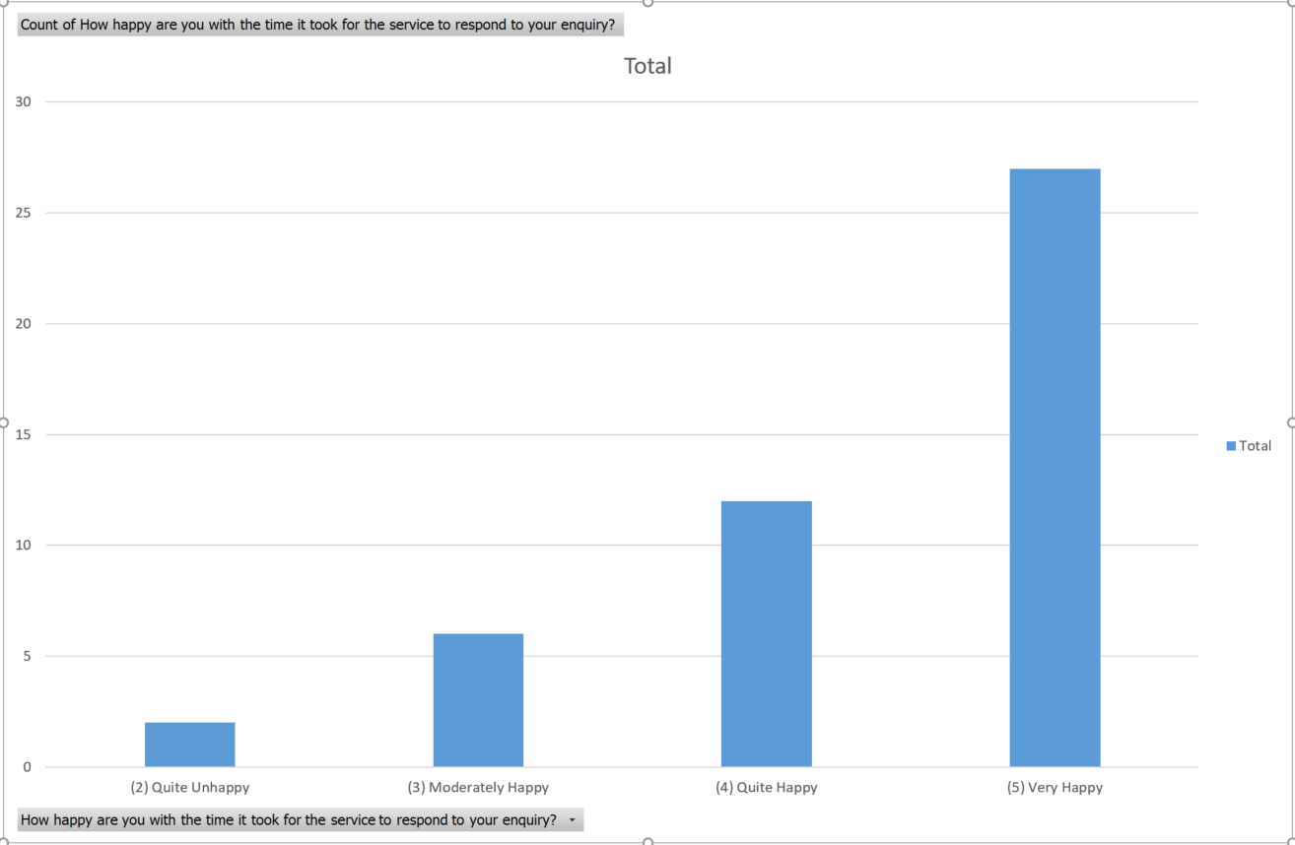

* 1. Members have completed 137 quality of response surveys since inception and 127 (93%) scored 3 or higher out of a 5-point scale. In FQ3 47 surveys were completed for quality and 44 (94%) scored them 3 or higher:

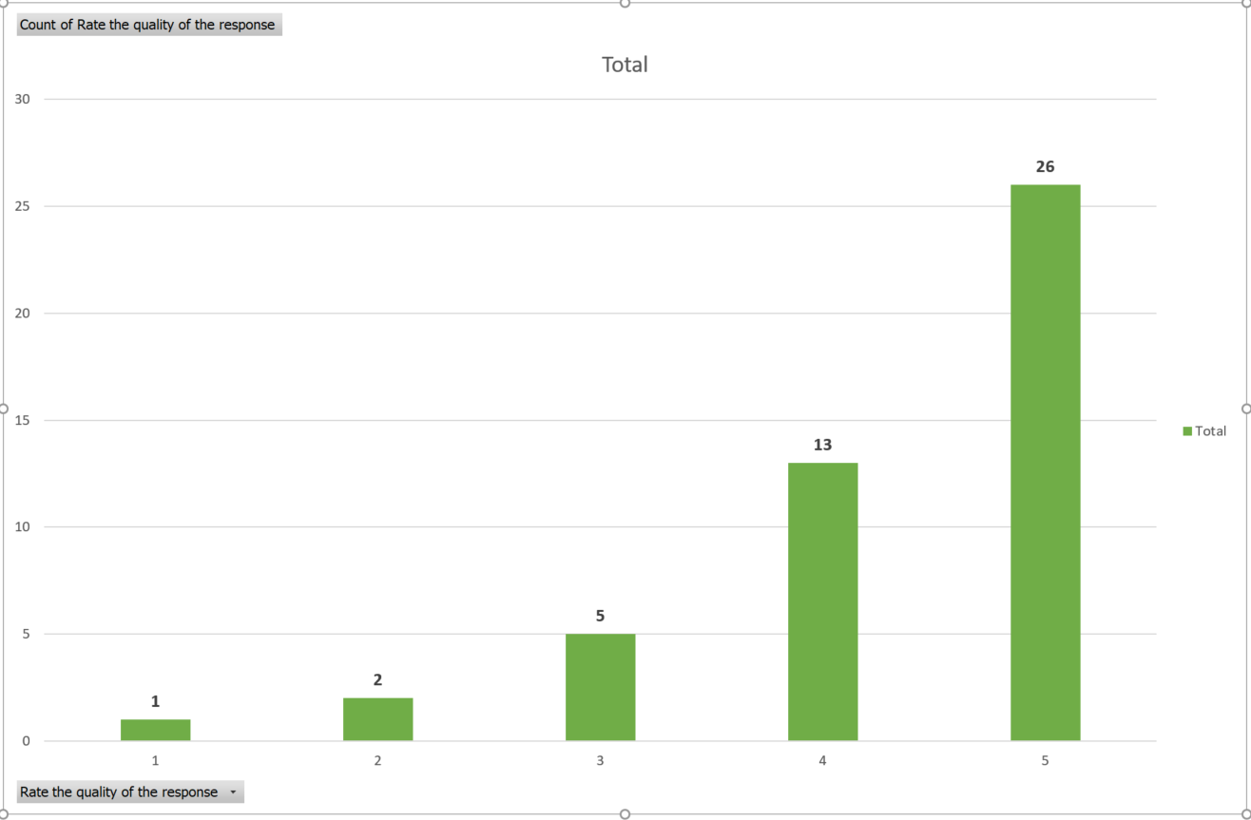

A number of positive comments were also made, with few negative ones:

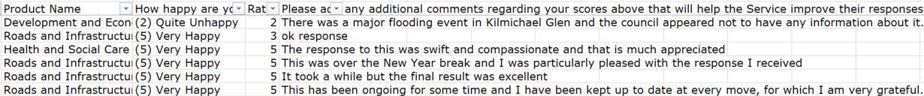

* 1. In addition to being the portal for the logging and management of Service Requests, Member Zone is also an information hub and we are continually adding resources, including all the Sounding Board Papers, tutorial videos and Briefings on the new functionality and weekly Operational Area Updates by RIS. New features added in FQ3 included:
* A link to the new Area Committee Scorecard Area committee scorecard button
* Links to the Customer Service Strategy Survey, Christmas Holiday Arrangements and the new 2024 Bin Calendars
* A link to Member Seminar documents.
  1. Three functional improvements were implemented in FQ3 and launched with appropriate guidance:
     + - A bespoke arrangement for logging of new emailed and voice mailed enquiries via the contact centre for a member with dyslexia and bespoke operational report to assist with caseload management.
       - A function to allow Directorate supports to escalate cases on MZ where a member has gone to a Director without first using the escalation process.
       - The ability for Services to remove an urgent marking on a case where the member has not used this function according to the guidelines.

The Sounding Board held in October (Appendix 1) agreed their future developments and a member led suggestion to add a case closure button on the emailed response from the Service to an enquiry has also been added to the development programme.

**4.0 CONCLUSION**

4.1 The Member Zone continues to evolve with input from members and Services. It is now a mature system with regular usage by the majority of members and has good feedback scores for quality and timeliness from those members that complete the survey. The live caseload fell slightly in FQ3 as fewer enquiries were logged and more cases were closed than came in.

**5.0 IMPLICATIONS**

| 5.1 Policy | None |
| --- | --- |
| 5.2 Financial | None |
| 5.3 Legal | None |
| 5.4 HR | None |
| 5.5 Fairer Duty Scotland |  |
| 5.5.1 - Equalities: | None |
| 5.5.2 - Socio-economic Duty: | None |
| 5.5.3 - Islands: | None |
| 5.6 Risk | Reduces risk of reputational damage and failure demand |
| 5.7 Climate Change | None |
| 5.8 Customer Service | Improvement in Constituent Enquiry Mgt. |

**For further information contact:**

Jane Fowler, Head of Customer Support Services

Bob Miller Customer Engagement Manager

**Appendix 1**: Minute of Fifth Member Zone Sounding Board, October 2023

**Appendix 1**: Minute of Fifth Member Zone Sounding Board, October 2023

**MINUTE OF MEMBER ZONE SOUNDING BOARD – MEETING 5**

**HELD ON 4th OCTOBER at 10am, VIA MS TEAMS**

|  |  |  |
| --- | --- | --- |
| **Present** |  | |
| Bob Miller | Customer Engagement Manager | |
| Jamie Robertson | Digital Engagement Services Developer | |
| Mark Calder  Susie Sinclair  Ailsa Barr  Jane Jarvie  Councillor Dougie McFadzean  Councillor Kieron Green  Cllr Iain Shonny Paterson | Project Manager RIS  Directorate Support Officer  Customer Liaison RIS  Comms Team Manager  Elected Member (part meeting)  Elected Member  Elected Member | |
|  |  | |
| **Apologies**  Councillor Mark Irvine  Councillor Liz McCabe  Councillor Fiona Howard  Helen MacLeod | Elected Member  Elected Member  Elected Member  Member Services Officer | |
|  | |

|  |  |  |
| --- | --- | --- |
|  |  | **Action** |
| **1** | **Welcome and introductions**  Bob welcomed everyone to the fifth meeting of the group, noted the apologies and thanked those who attended. |  |
| **2** | **Minute of Previous Meeting**  The meeting reviewed and accepted the minute of the previous meeting held in June 2023. It noted that all the actions were either completed or were covered later in the agenda.  The action regarding the MZ session at the Member Seminar (being held the next day), was reviewed in detail and BM ran through the draft slide set. Attendees suggested a number of useful amendments and additions and BM will update the slide deck accordingly. Cllr McFadzean also kindly agreed to talk from personal experience about the benefits of MZ. The final slide deck is on the seminar page of the Hub. | **Bob/ Cllr McFadzean** |
| **3** | **Review of Current Member Zone Request Portal Performance**  The latest Request Management Update Briefing covering MZ performance up to 22/10 was provided and it was noted that some of the concerns will be covered off at the Members’ Seminar, including:   * + - * The cohort of Councillors who have low usage of MZ, although Cllr Green noted that he was vigorous in directing constituents to self-serve so that cases were not needlessly logged in MZ that could be done using online forms.       * The need for members to close cases off that had been responded to as there were now over 500 in this category. Jamie noted that the glitch with auto close function noted at the previous meeting had been rectified and so far 14 cases had been auto closed.       * The under use of the survey offered to members whenever they closed a case; only 91 surveys completed to date, but these indicated over 90% satisfaction with both quality and timeliness of service.   No other issues were reported by RIS or Digital Team attendees. Mark updated the group that he would shortly be leaving RIS for a secondment to the Comms Team and that until a replacement was appointed, Anna Alderson in his team would be lead operational contact for MZ queries. | **Bob** |
| **4** | **Current in progress and planned MZ system developments**  Bob noted that the Digital Development Team had lost two of its 4 staff to maternity and secondment, so MZ development had been curtailed over the previous quarter.  Jamie updated on the current priority developments as follows:   * The satisfaction survey change to differentiate between satisfaction with handling of a request and its actual outcome was nearing completion and would be ready to test the following week. * The improvement Red, Amber Green visual status in member’s open caseloads is in progress with help from the Web Team to achieve this. * The new form for Planning related enquiries has been implemented. * Copying/attaching of emails to requests (Cllr Wallace) is more complex as it involves MS Outlook and will require time. * The enabling the reporting of Section Faults by Members (something CSC agents can do) is part of the current WDM to Cloud Project, which is still in progress. | **Jamie** |
| **5** | **Member Zone Information Resources**  Bob noted that the action to add out of hours emergency number to the MZ library was completed.  Mark advised that new 2023-24 Winter Roads Policy had also been added to the library and web content is being reviewed ahead of the Winter Maintenance Season.  Bob also noted that as one of the presentations he is giving to the Members’ Seminar tomorrow is on the use of Intelligent Automation in ABC, he has added a paper called “Generative AI – A Guide for Local Authorities” to the library as it is a topical subject with the advent of Chat GPT etc.  Mark will consider what additional topical or seasonal RIS briefings could be added to the library (possibly one relating to the Bridge Maintenance Fund) and noted that the Weekly RIS update is still being added, although a recent survey of members by RIS on the format/content of the Briefing elicited responses from only 4 members. | **Mark** |
| **6** | **Member Support**  Bob noted that Helen was not able to attend the meeting but he had not been made aware of any issues. |  |
| **7** | **A.O.C.B.**  Councillor McFadzean asked about how formal complaints were reflected in MZ and if they were counted in the totals reported to the Audit and Scrutiny Committee. Bob replied that as the complaints system was a statutory one that gave customers possible recourse to the Ombudsman, they were kept separate from MZ. Complaints reported to A&S Committee had to be raised by the customer via that system. That did not preclude the citizen from also involving their member, but it would be handled via the complaints system.  As there was no other business Bob thanked all attendees for their positive input. |  |
| **8** | **Date of Next Meeting**  The Board agreed that the next meeting would take place in January when the FQ3 MZ statistics were available. | **Bob/Susie** |