
Member Zone Sounding Board – Meeting 7
Friday 27th September at 10am by Teams
AGENDA

1 | Welcome, introductions, apologies. | Bob
2 | Minute of Previous Meeting 19th March 2024 (herewith) | All
3 | Review of current Member Zone Request Portal Performance:  - 2022-24 and FQ1 2024/5 Report to SMT (herewith)  - FQ2 2024/25 Request Management Update Briefing (herewith)  - Backlog of aged ‘Response Provided’ Cases with Members  - Operational Issues (Members’ and Officers’ perspectives)  - System Issues (Jamie Robertson to lead) | Group Discussion
4 | Current in Progress and Planned MZ System Developments  - Development Programme List Completed over past period:  - Random Case Selector for RIS Quality Control  - Closure via email Hyperlink (Update)  - Five most used enquiry types being added as dedicated forms on Member Zone: See MZ Update Briefing 7 of June 2024 (herewith)  - Enhanced DMT Monthly Report (Example herewith)  - Outstanding and Planned:  - Red, Amber Green visual status in member’s open caseloads.  - Attaching of emails to requests  - The enabling the reporting of Section Faults by Members to WDM  - Upload/transfer of photographs and attachments via MZ to WDM  - Logging of MZ requests on the move (WIP Staging solution). | Group Discussion
5 | Member Zone Information Resources  - Operational Updates to Edition 163 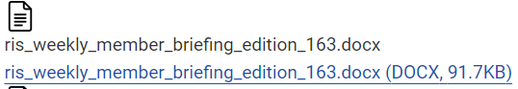  - New Accessibility Tool on Portal 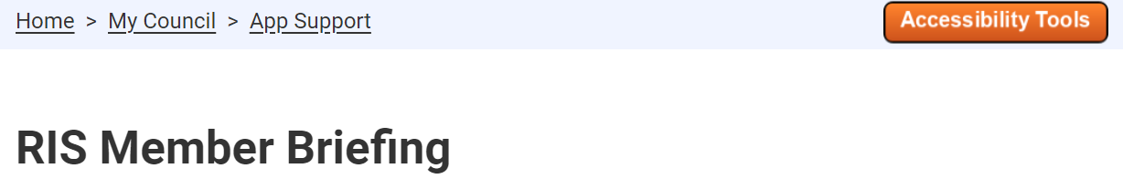  - Sounding Board Papers  - Wish List? | Group Discussion
6 | Member Support:  - Member Services Support (Helen)  - Other support or training needs and onboarding of new Members | Group Discussion
7 | AOCB  - Review of MZ Sounding Board Terms of Reference (herewith) | All
8 | Date of Next Meeting – March 2025? | TBC

